SUBCOURSE EDITION
QM3853 A

EXTERNAL COORDINATION, PART III



EXTERNAL COORDINATION, PART III

Subcourse Number QM3853
EDITION A

United States Army Combined Arms Support Command
Fort Lee, Virginia 23801-1809

5 Credit Hours

Edition Date: September 1991

SUBCOURSE OVERVIEW

This subcourse is designed to teach you how to coordinate external food service operations. Contained within this subcourse is information on how to coordinate with the facilities engineers on training personnel in operating and maintaining equipment in garrison. You will also learn how to coordinate requirements for food service operations for major exercises and medical facilities. In addition, you will learn general Army standards on sanitation, nutrition, and menus. This information will assist you in coordinating with The Surgeon General (TSG) to ensure that troops are fed according to standards. Finally, you will learn how to coordinate with veterinary personnel when handling unsatisfactory subsistence.

There are two prerequisites for this subcourse which must be completed before you begin studying the material contained within this subcourse:

QM 3851, External Coordination, Part I.
QM 3852, External Coordination, Part II.

This subcourse reflects the doctrine which was current at the time it was prepared. In your own work situation, always refer to the latest publications.

The words "he," "him"," "his," and "men," when used in this publication, represent both the masculine and feminine genders unless otherwise stated.

TERMINAL LEARNING OBJECTIVE

TASK: You will coordinate external food service operations.

i QM3853

CONDITIONS: You will have information from AR 30-1, AR 30-18, AR 420-55, FM 10-23, FM 10-26, FM 25-2, and TB MED 530.

STANDARDS: You will coordinate external food service operations in accordance with AR 30-1, AR 30-18, AR 420-55, FM 10-23, FM 10-26, FM 25-2, and TB MED 530.

ii QM3853

TABLE OF CONTENTS

Section Page

Subcourse Overview i

Lesson: Coordinating External Food Service Operations 1

Part A: Coordinate with the Facilities
Engineers for Garrison Equipment
Operation and Maintenance Training 2

Part B: Coordinate Food Service Operations and
Requirements for Major Exercises and
the Medical Facility 8

Part C: Coordinate with the Surgeon on Sanitation,
Nutrition, Nutrition Surveys, and
Menu Testing 38

Part D: Coordinate with Veterinary Personnel
Concerning Unsatisfactory Subsistence
Products 52

Practice Exercise 59

Answer Key and Feedback 62

The passing score for this subcourse is 70%.

iii QM3853
LESSON

COORDINATING EXTERNAL FOOD SERVICE OPERATIONS

MQS Manual Tasks: 03-5106.00-0068
03-5106.00-0092
03-5106.00-0096
03-5106.00-0154
03-5106.00-0155

OVERVIEW

TASK DESCRIPTION:

In this lesson, you will learn to coordinate external food service operations.

LEARNING OBJECTIVE:

TASKS: You will identify procedures to coordinate external food service operations.

CONDITIONS: You will be given information from AR 30-1, AR 30-18, AR 420-55, FM 10-23, FM 10-26, FM 25-2, and TB MED 530.

STANDARDS: Coordinating external food service operations will be in accordance with AR 30-1, AR 30-18, AR 420-55, FM 10-23, FM 10-26, FM 25-2, and TB MED 530.

REFERENCES: The material contained in this lesson was derived from the following publications:

AR 30-1
AR 30-18
AR 420-55
FM 10-23
FM 10-26
FM 25-2
TB MED 530

INTRODUCTION

As a food advisor/technician, you are responsible for ensuring that food service operations run smoothly and according to regulations. You must know how to coordinate with facilities engineers for operation and maintenance training on equipment in

1 QM3853

garrison. Whenever a facility receives new equipment, or if there are too many equipment problems, food service personnel may need training.

Planning a major exercise requires coordination between numerous agencies and people. You must know how to determine needs and who to coordinate with to fulfill all requirements. You must also ensure that food service requirements are fulfilled for medical facilities.

You coordinate with the surgeon on sanitation and nutrition standards. Battles are lost due to diseases caused by poor sanitation and inadequate nutrition for soldiers. You must know Army standards in these areas to ensure that standards are followed and enforced.

If personnel suspect that subsistence is unfit for human consumption, contact veterinary personnel to inspect the subsistence. They will determine if subsistence is indeed unfit and advise on disposal methods.

PART A - COORDINATE WITH THE FACILITIES ENGINEERS FOR GARRISON
EQUIPMENT OPERATION AND MAINTENANCE TRAINING

1. Overview.

Whenever a dining facility receives new equipment, you must ensure that personnel are thoroughly trained before they operate the equipment. Once you have identified the personnel to be trained, you must select an appropriate training location such as a classroom or on the job. Coordinate the training schedule with the unit to ensure that your selected location is available. Prepare a written request to train food service personnel. Include the following in your request: number of personnel to be trained; type of equipment upon which personnel will receive training; location of training; date and time of training; and support needs such as manuals, warranty information, or audiovisual equipment. Submit the written request to the Director of Engineering and Housing (DEH).

When the request for training is approved, distribute training schedules to the appropriate units. Always monitor the training and conduct follow-up training as required.

2. General Operation and Maintenance Procedures.

a. Obtaining Manufacturer's Technical Manuals. Operational dining facilities are to be provided with a copy of the manufacturer's technical manual for each item of mechanical food service equipment. Two copies of all manuals should be provided

2 QM3853

with each new piece of equipment; one is kept in the dining facility and the other is kept by the supporting facilities engineer. If the copies are not included with new equipment, a General Services Administration (GSA) Standard Form (SF) 368, Quality Deficiency Report (QDR) should be submitted. Information copies of GSA SF 368 are furnished to major Army command (MACOM) and the Army Center for Excellence, Subsistence (ACES), Fort Lee, VA 23801-5041. If the manufacturer's technical manual for an existing piece of equipment is unavailable, the food service sergeant (FSS) should contact the installation food advisor or the Director of Engineering and Housing (DEH).

b. Obtaining Manuals for the Installation. If manuals are not available at the installation, assistance can be requested from ACES at the above address. Operator and maintenance manuals for Federal Supply Class (FSC) 4110, 7310, and 7320 refrigeration and food service equipment are listed in Defense Supply Center Manual 4140.1. The request should include all information contained on the equipment data plate, such as national stock number (NSN), nomenclature, manufacturer, make, model, and contract number.

c. Requesting Training. A training program for proper operator maintenance of food service equipment for all dining facility personnel should be requested from the DEH.

d. Establishing and Maintaining DA Form 2405 (Maintenance Request Register). The FSS or contractor establishes and maintains the DA Form 2405 (Maintenance Request Register) in the dining facility. A properly maintained register is used as a historical record of equipment failure(s) and as a means to determine uncompleted work requests requiring follow-up actions. This register also serves as a ready source to answer questions on maintenance requests and as a means for formulating budget requests when the cost of repair(s) exceeds the maintenance expenditure limits as outlined in the Technical Bulletin for the equipment.

3. Procedures for Removing, Maintaining, and Repairing Food Service Installation Equipment.

This section applies to all Department of the Army (DA) installations and activities owned and/or controlled by the DA, including those in full-time or intermittent use by the Army National Guard (ARNG), US Army Reserve (USAR), and Reserve Officers' Training Corps (ROTC).

3 QM3853

a. Explanation of Terms.

(1) Direct Maintenance/Repair Supports. This is the performance of preventive and routine maintenance and minor repairs by facilities engineers.

(2) Energy Efficiency. This is the ratio of energy output of food service (or related) equipment or appliances to input energy. Efficiency can be determined through test procedures contained or identified in a Voluntary Energy Conservation Specification published by the US Department of Commerce available from Public Documents Distribution Center, Pueblo, Colorado 81009.

(3) Food Service and Related Food Service Equipment.

o Food service equipment includes mechanical, cooking, and other equipment excluding utensils used in preparing, processing, and serving foods.

o Related food service equipment includes items of equipment used in support of the preparation, processing, serving, and preservation of foods; disposition of garbage; and cleaning of wares. For example, dish, pot, and pan washing equipment and ventilation hoods are related food service equipment items.

o Installed air conditioning, refrigeration (for example, built-in reefers), and ventilation equipment except hoods are not food service or related equipment.

o Food packaging and processing equipment used in commissaries are not food service equipment.

(4) General Maintenance/Repair Support. This is the performing of major repair, overhaul, and associated maintenance by depot support or contract personnel.

(5) Operator Maintenance Support. This is the performance of minor maintenance functions by individuals using the equipment. Replacing filters, cleaning coils in steam tables, and keeping equipment clean are examples of operator maintenance tasks.

(6) Utilities Characteristics. This is the rated system or equipment design characteristics for electrical, mechanical, and sanitary services, such as: voltage, frequency, amperage, wattage, steam pressure, water pressure, drain size, hourly energy consumption, and energy efficiency ratio.

4 QM3853

b. Responsibilities.

(1) Facilities Engineer. The facilities engineer is responsible for the following functions.

o Installation, removal, maintenance, and repair (other than operator maintenance) of appropriated fund procured food service and related equipment in existing facilities.

o Determination of serviceability and repairability of equipment.

o Establishment of training programs and conducting user training in the operation, preventive maintenance, and energy conservation of food service and other related food service equipment. Programs include instructions regarding the maintenance and cleaning of grease interceptors, where applicable.

o Assurance that the following fire protection criteria are met:

- Cooking equipment is installed in accordance with National Fire Protection Association (NFPA) Standard 96, Section 10, available from the NFPA, 470 Atlantic Avenue, Boston, MA 02210.

- Extinguishing systems are installed in accordance with NFPA Standard 96, Section 122.

- Deep fat fryers conform with NFPA Standard 96, Section 122.

o Inspecting, testing, and certifying that microwave ovens are safe to operate.

(2) Army Center for Excellence, Subsistence (ACES). ACES, a field operating agency under the jurisdiction of the Headquarters, Department of the Army (HQDA), Deputy Chief of Staff for Logistics (DCSLOG), is responsible for the following.

o Implementing the Army Food Service Program, except at hospital and club dining facilities.

5 QM3853

o Assisting in the planning, review, and justification of programs for military construction, minor construction, operator maintenance, space allocations, and functional equipment layouts and criteria.

o Recommending authorization criteria and type-description for troop support equipment. Common table of allowances (CTA) 50-911 prescribes allowances of food service and related equipment for dining facilities or Army vessels.

c. Criteria for Maintenance and Repair Decisions.

(1) Scheduled and Preventive Direct Maintenance Support. This food service equipment maintenance should be established using the most stringent criteria obtained from equipment manufacturer's recommendations, specific DA publications, the energy conservation program, or mission requirements. Basically, it is the performance of routine maintenance to preclude any avoidable breakdowns.

(2) General Repair Support. General repair support is to be done using the most economical means, determined through periodic engineering analyses of available alternatives.

(3) Determining That Equipment Is Not Economically Repairable. Final determination of equipment repairability is made by the facilities engineer or his representative. Upon the determination that equipment is not economically repairable, the facilities engineer specifies in writing the basis for his decision. This signed written statement is provided to the appropriate command supply activity as the basis for requisitioning the equipment.

(4) Criteria. The following criteria are used as the bases for determining when food service and related equipment is not economically repairable.

o Replacement parts are not obtainable through local purchase, cannibalization, or from the equipment manufacturer.

o General repair support requirements for a given job exceed the capabilities of local government or commercial repair shops.

o The initial and/or cumulative repair cost is excessive. Age, general condition, and replacement cost of the equipment is evaluated as part of the determination process.

6 QM3853

(5) Equipment Not to Be Classified as Uneconomically Repairable. Equipment is not classified as economically unrepairable under the following conditions.

o Equipment is insufficient in size or capacity to support its intended or actual applications.

o Utilities characteristics of the facility are different or noncompatible with those of the equipment item.

d. Requisitions for Replacement or Acquisition. Requisitions for food service and other related equipment must be coordinated with the facilities engineer and reflect minimum essential requirements within the prescribed allowances. Also the space and utility requirement must be considered when equipment is being requisitioned. If the building used to house the equipment requires changes in utility requirements, the funding for these changes must be approved and programmed before the equipment arrives. Also, requisitions must include the following:

o The name of the installation or activity.

o The MACOM.

o The NSN (if cataloged).

o Nomenclature.

o Space or dimensional limitations.

o The age of the equipment being replaced; estimated if unknown.

o Facilities engineer's statement.

o Complete utilities characteristics affecting the equipment for the building in which it is to be installed, including the positive or negative impact on energy consumption.

o Certification that funds are available for installation and that authority (like administrative approval of a proposed project) has been granted to install the equipment.

o Complete description of requisitioned item in the remarks block.

7 QM3853

o Minimum acceptable energy efficiency ratio, where applicable.

e. Engineering Economic and Conservation Criteria.

(1) Energy Source Selection. The energy source selected for operating food service and related equipment is evaluated at the time the equipment is replaced or upon alteration or construction of a facility. All energy source alternatives expected to be available during the predicted useful life of the equipment should be considered. Final energy source selection is based upon the lowest life cycle cost alternative for the equipment application as determined from an engineering evaluation.

(2) Energy Efficiency. The Energy Policy and Conservation Act of 1975 requires labeling of certain appliances and equipment to promote effective energy conservation. The most efficient food service and related equipment should be procured as identified by its label whenever such an alternative exists.

(3) Energy Recovery. A substantial quantity of heated air usually exits through ventilation hoods in kitchen areas. To reduce the cost of heating dining facilities and conserve energy, consideration must be given to installing energy recovery equipment (for example, rotary air-to-air heat exchangers, static heat exchangers, heat pipes, and run-around systems) in conjunction with projects involving major food service and related equipment installations.

(4) Repair Parts. The facilities engineer obtains repair parts through the military supply system or from commercial sources. Under exceptional circumstances, it may be desirable or necessary to fabricate major replacement parts. Parts from salvaged equipment are to be used to the fullest possible extent.

PART B - COORDINATE FOOD SERVICE OPERATIONS AND REQUIREMENTS
FOR MAJOR EXERCISES AND THE MEDICAL FACILITY

1. General Preparations for Field Training.

Before a major exercise, review evaluation reports of past exercises to correct past errors or problems. One of your responsibilities is to evaluate the effect the exercise has upon dining facilities. It may be necessary to consolidate or close facilities. Another responsibility is to provide input to G4 on Class III requirements. This part of the lesson provides you with the necessary information needed to perform your job when preparing for major exercises.

8 QM3853

a. Operational Rations. Operational rations are issued primarily for training, troop movements, and in support of a theater of operations. Individual packaged rations are usually not used as the sole diet subsisting troops for over 10 days; the Army peacetime feeding standard is two hot meals per day when the tactical and logistical situation permits.

b. Box Lunches. Box lunches can also be used for troop movements to or from the cantonment area and field location.

c. Field Equipment. Modification Table of Organization and Equipment (MTOE) field kitchen equipment is to be used during all field training. Field expedients that replace or modify MTOE equipment, such as fabricated griddles, butane-fired or charcoal grills, or any other unauthorized equipment are not to be used. Available installed food service equipment can be used during training at armories or during garrison operations on a military installation. Cargo trucks must not be modified for conversion to mobile kitchen trucks, but vehicles already modified as kitchen trucks can continue to be used until the mounted field kitchen trailer is received. However, the use of a kitchen truck to prepare subsistence while in movement or for sole use instead of the kitchen tent or general-purpose tent is not authorized.

d. Training for Each Skill Level. Planning includes scheduling field training exercises. A well-developed plan provides effective training for troops at all grade levels: soldiers at skill level 1 (E4) practice basic skills; soldiers in grades E5 and E6 practice instruction and supervision; upper-level managers such as noncommissioned officers (NCOs) in grades E7, E8, and E9, and officers, observe operations and training and counsel junior leaders on their performance. NCOs also evaluate the unit training status and revise training plans according to their evaluation.

e. Coordination Between Dining Facility and Field. Before an exercise begins, you work with the installation staff to coordinate the closing and consolidating of dining facilities. You also plan for the transfer of garrison missions that are usually done by subsistence supply units to Troop Issue Subsistence Activity (TISA). Other preparations include developing loading plans for field kitchens; coordinating supply support among TISA, ration breakdown points, and field kitchens; planning for cross-service reimbursement during joint training exercises; and determining subsistence support requirements. You are also expected to provide guidance on food service problem play in the exercise scenario.

9 QM3853

2. Training Schedule Preparation.

a. List All Information. Training schedules list the individual leader and collective tasks to be trained and evaluated. They state how training time is to be used by all the unit's soldiers. Also the training schedules confirm guidance given to trainers, publicize training to unit members, and coordinate all unit personnel activities. Training schedules can be developed as guidance from short-range planning becomes known. They are developed in detail as training deadlines approach.

b. Prepare Schedule for Active Component Units. In active component units, weekly training schedules are usually prepared by company commanders 3 to 12 weeks ahead of time and are published 2 weeks before training.

c. Prepare Schedule for Reserve Component (RC) Units. Reserve component units develop and publish training schedules at least three months before training. Each training schedule lists the training assemblies for that month and the following two months. RC commanders have the authority and responsibility to structure unit training assemblies and multiple unit training assemblies so their units derive the maximum training benefit from them. Units should add a new monthly training schedule after the current month's training is conducted. The closest month's schedule is then finalized and the remaining are further detailed and coordinated. Training meetings coordinate the next training assembly and provide input for future schedules.

d. Limit Changes to Schedules. Commanders act as buffers to limit training schedule changes by higher headquarters and external agencies. They also activate changes in subordinate units. This reduces turbulence (crisis management) and ensures that planned training occurs as scheduled. This type of stability also causes higher headquarters staffs and other outside agencies to plan their taskings well in advance and makes everyone in the chain of command aware that training is considered the first priority.

e. Coordinate and Schedule Training. Headquarters company-level commanders coordinate and schedule staff training with the senior commander and staff; the best way to do this is at training meetings.

f. Involve Subordinates in Drafting Schedules. Company commanders should involve their immediate subordinates in drafting training schedules. Subordinates involved in the training process provide useful ideas about preparing for, scheduling, and supporting training. They can also help in assigning training priorities.

10 QM3853

g. Draft a Training Schedule. There are many ways to draft a training schedule. Figure 1 is an example of a unit training schedule stating the unit name, when the training is scheduled, what the training is on, and who is involved. These items are separated by columns. The following steps help company-level commanders with this task.

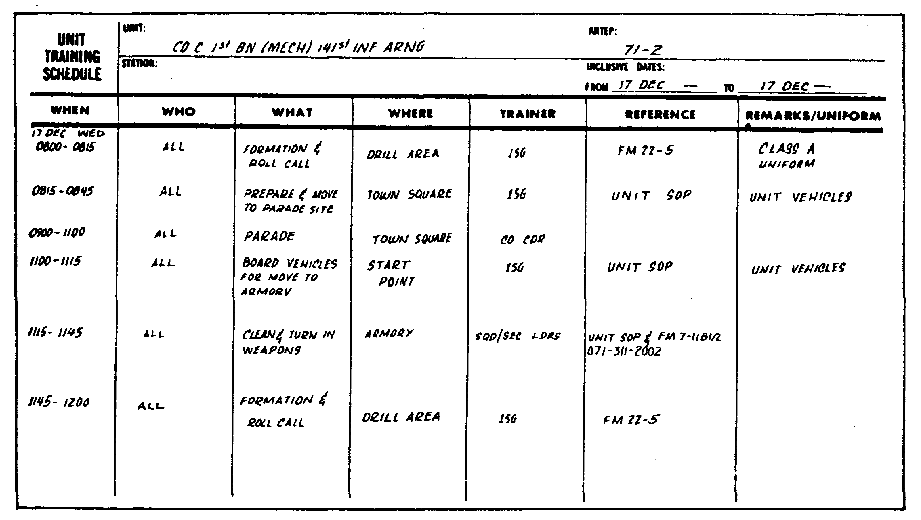

Figure 1. Sample Training Schedule for RC Units.

(1) Step 1: Schedule Training Needing Specific Resources or Locations. First consideration should be given to training that requires specific locations, equipment, personnel, time, or other resources that may dictate how, where, or when training is given. For example, some tasks are best trained in garrison; others may require a field setting.

(2) Step 2: Schedule Training Required by Higher Headquarters. As events required by higher headquarters are scheduled, the need for more training may surface. For example, a requirement to conduct qualification firing with the M16 rifle may highlight a need to give leaders refresher training on operating ranges. It may also require several hours of preliminary marksmanship instruction for soldiers.

(3) Step 3: Schedule Remaining Events. Once training requiring specific resources and events designated by higher headquarters are scheduled, the company-level commander fits in

11 QM3853

all other activities. Some major events require scheduling preliminary training, for example, leader training with war games in preparation for a large-scale field training exercise (FTX).

(4) Step 4: Consider Training That Does Not Have to Be Scheduled. Some training can be done by requiring subordinate leaders to find the time within other scheduled events or activities. This is opportunity (hip-pocket) training. Commanders must plan for the use of unexpected training time. Tasks for opportunity training should be designated as notes on the training schedule and should be considered as orders. The following are examples of how opportunity training time becomes available.

o A trainer does not use the entire period to train a scheduled task.

o A pretest shows that soldiers are already proficient in the scheduled task.

o Scheduled transportation is delayed.

o Soldiers are waiting for their turns in the firing line.

(5) Tips for Preparing Schedules. Regardless of the training, the following are some tips to remember when preparing a training schedule.

o State the training requirements in terms of what is to be accomplished.

o Designate a time period for each training session, but allow training to end earlier if soldiers attain proficiency or to continue if more time is needed. Each training session should allow time for leaders to verify proficiency after training is completed.

o Allocate time and resources based on need.

o Include training for all echelons and members of the unit.

o Allow time requested by platoon, squad, or section leaders to accomplish the requirements.

o Consider training portions of a task if time does not allow the entire task to be trained. (Use subtasks or selected performance measures in the soldiers' manuals.)

12 QM3853

o Indicate tasks for opportunity or hip-pocket training.

h. Submit the Training Schedule. Once the schedule has been drafted, the company commander should submit it to the commander and staff, especially the G3 or S3, for coordination and approval. The commander and staff can then arrange for support, take necessary resource actions, plan for evaluations, and make adjustments as needed. This process facilitates final approval and publication of the training schedule.

i. Reduce or Avoid Changes in Training Schedules. After the training schedules are approved, changes should be reduced or avoided. This results in the following.

o Elimination of last minute changes experienced in units.

o Planned training occurring as scheduled.

o Earlier scheduling of tasking requirements by higher headquarters commanders and staffs.

o Increased visibility of the training priority.

o Company-level leaders gaining confidence because training occurs as planned.

j. Prepare Exercise Plans. Training schedules are supplemented by exercise plans. These are needed to control the more complex exercises such as command post exercises (CPXs), FTXs, or external evaluations. Exercise plans provide the necessary detailed information that is not included in training schedules. They coordinate the trainers, evaluators, controllers, support personnel, opposing forces (OPFOR), and others. The commander planning the exercise specifies the training objectives to be met. This information is used by subordinate leaders and staff to plan, coordinate, and take resource actions for the entire event.

k. Exercise Plans for Smaller Units. Smaller training events may not need a comprehensive exercise plan. Notes on the training objectives and sequence of activities may be sufficient. More complex exercises, such as a combined arms field exercise lasting several days, require a scenario based on the threat; a detailed operation order; or a letter of instruction (LOI) with evaluation, control, OPFOR, support, and communications annexes. The exercise plan should be as simple as possible while meeting the objectives of the training exercise.

13 QM3853

l. Key Actions to Planning an Exercise. The following basic actions are key to planning an exercise.

o Analyzing requirements, guidance, and unit needs.

o Prescribe training objectives and guidance.

o Prepare and issue an exercise order.

o Prepare a planning schedule.

o Plan task and resource responsibilities.

o Prepare a scenario outline.

o Conduct reconnaissance.

o Complete the scenario.

o Complete the exercise plans.

o Prepare an operation plan.

o Obtain and prepare resources.

o Rehearse (as required).

3. Predeployment Planning.

a. Cook Allocations. The Army Field Feeding System (AFFS) provides for a sufficient increase of food service personnel above Combat Field Feeding System (CFFS) authorizations for preparation of T, A, and B Ration meals. The enhanced cook allocation does not allow unlimited A Ration meal preparation; however, it does support the revised DA wartime feeding policy of a hot A Ration meal every third day when tactical and logistical situations permit. Cooks are allocated to fixed structure battalions and qualifying separate companies based on the manpower and requirements criteria (MARC) process conducted during May and June 1988. Each fixed structure battalion and headquarters and headquarters company (HHC) and headquarters and headquarters detachment (HHD) of nondivisional battalions is allocated an FSS. Also, each mobile kitchen trailer (MKT) is allocated a working food service supervisor (first cook).

(1) Divisions, Separate Brigades, and Armored Cavalry. Under the AFFS for divisions, separate brigades, and Armored Cavalry Regiments (ACR), cooks are consolidated at battalion level for fixed structure organizations (battalions with a fixed number of subordinate units). Some exceptions to the concept of consolidating cooks at battalion level are necessary in taking

14 QM3853

into account how units are deployed and operate on the battlefield. These exceptions include the following.

o Forward support medical companies of divisional medical battalions are staffed to feed required personnel and 50 percent of their patient load.

o In the light infantry divisions, the division artillery (DIVARTY), HHC, and the 155 batteries are assigned their own food service teams.

o The multiple launch rocket system (MLRS) has its own food service team.

o The divisional aviation maintenance company has its own food service team.

(2) Echelons Above Division (EAD) and Nondivisional. EAD separate companies with a strength of 100 or more are provided cooks at company level based on the personnel strength supported. Fixed structure battalions in echelons above corps (EAC)(artillery, engineers, air defense, and aviation battalions) are treated the same as their divisional counterparts and are authorized cook spaces accordingly. Nondivisional separate units with a required strength of less than 100 are not provided food service personnel, but coordinate with nearby feeding units for support under the area feeding concept.

b. Class I and Food Support. Although logistical planning for FTXs is limited in scope compared to actual battlefield conditions, understanding Class I and food service support planning techniques reduces the transition to combat.

c. Requirements. Food service and Class I requirements are first considered in the predeployment planning process. Factors affecting predeployment planning are the field menu, the ration mix, ration requirements, supplemental and enhancement items, warming beverages, substitutions and deletions, the Class I distribution system, water, fuel, ice, waste disposal and residuals.

(1) Field Menu. You must first designate the field menu and determine if its components are available. The Army field feeding standard is one meal, ready-to-eat (MRE) and two hot T Ration meals per day with two A Ration meals authorized in a seven-day period when the tactical and logistical situations permit. The number of separate line items needed to support the AFFS feeding standard has significantly decreased. However, the importance of determining a field menu and accurately and quickly forecasting Class I requirements is still vital to a successful FTX or unit deployment.

15 QM3853

(2) Ration Mix. The FTX ration mix is a second factor each unit determines and must be considered when conducting predeployment Class I and food service planning. Two hot meals (T and A Ration) are usually given for breakfast and dinner with an operational meal for lunch. However, the ration mix can change with the unit type, tactical scenario, day, and type of exercise and deployment. The ration mix is normally represented as T-MRE-T. This indicates that the unit is scheduled to consume a T Ration breakfast, an MRE lunch, and a T Ration dinner. Other possible examples of ration mixes, depending on the unit mission, can be T-MRE-MRE, MRE-MRE-T, MRE-MRE-MRE, or A-MRE-T.

(3) Ration Requirements. Unit Class I ration requirements are based primarily on three factors: the present for duty strength, type of ration, and number of remote sites.

(a) Requesting Rations. A Rations are requested by meal and MREs are requested by box, based on the total number to be fed. T Ration requirements are determined by the total number fed divided by 36 (T Ration modules are packed for 36 soldiers). Any resulting fraction must be rounded up to the nearest whole number. For example, if the projected present for duty strength for the first day's breakfast is 10,000 soldiers:

10,000 = 277.7 = 278
36

In this example, 278 T Ration modules are requested. The T Ration is packaged in 12 or 18 serving size tray pans and is served from its original tray. Due to this unique packaging, the larger the number of remote sites a unit is supporting, the greater the number of T Rations requested. For example, if the FSS knows that one remote site has 12 soldiers, a second remote site has 11 soldiers, and a third remote site has 9 soldiers, one 36-soldier module would satisfy this requirement if the main entree pan size is 12 (there are 3 entree pans in a 12-serving module). However, if the pan size for this particular meal was 18, the FSS orders 2 modules, since there are only 2 entree pans in a module if the pan has 18 servings. Other factors can be used as guides to planning a successful field training mission. These include--

o Your experience from past exercises.

o Additional feeding requirements from the area feeding concept or task organization.

o The tactical posture of the unit.

o The duration and the day of the exercise.

16 QM3853

o The weather conditions.

o The availability of field kitchen equipment.

(b) Class I Spreadsheet. One method frequently used to assist you in planning and managing ration requirements by unit is to prepare a Class I spreadsheet. This allows you to see the Class I and food requirements in all the units you are supporting. You get the information to prepare the spreadsheet from unit feeder reports and ration requests. It can also be expanded to include remote site feeding data. Figure 2 is an example of a Class I spreadsheet that states specific ration mixes based on the present for duty strength and the day of the exercise; for example, day one (N) = MRE-MRE-MRE; and day two (N+1) = MRE-T-MRE.

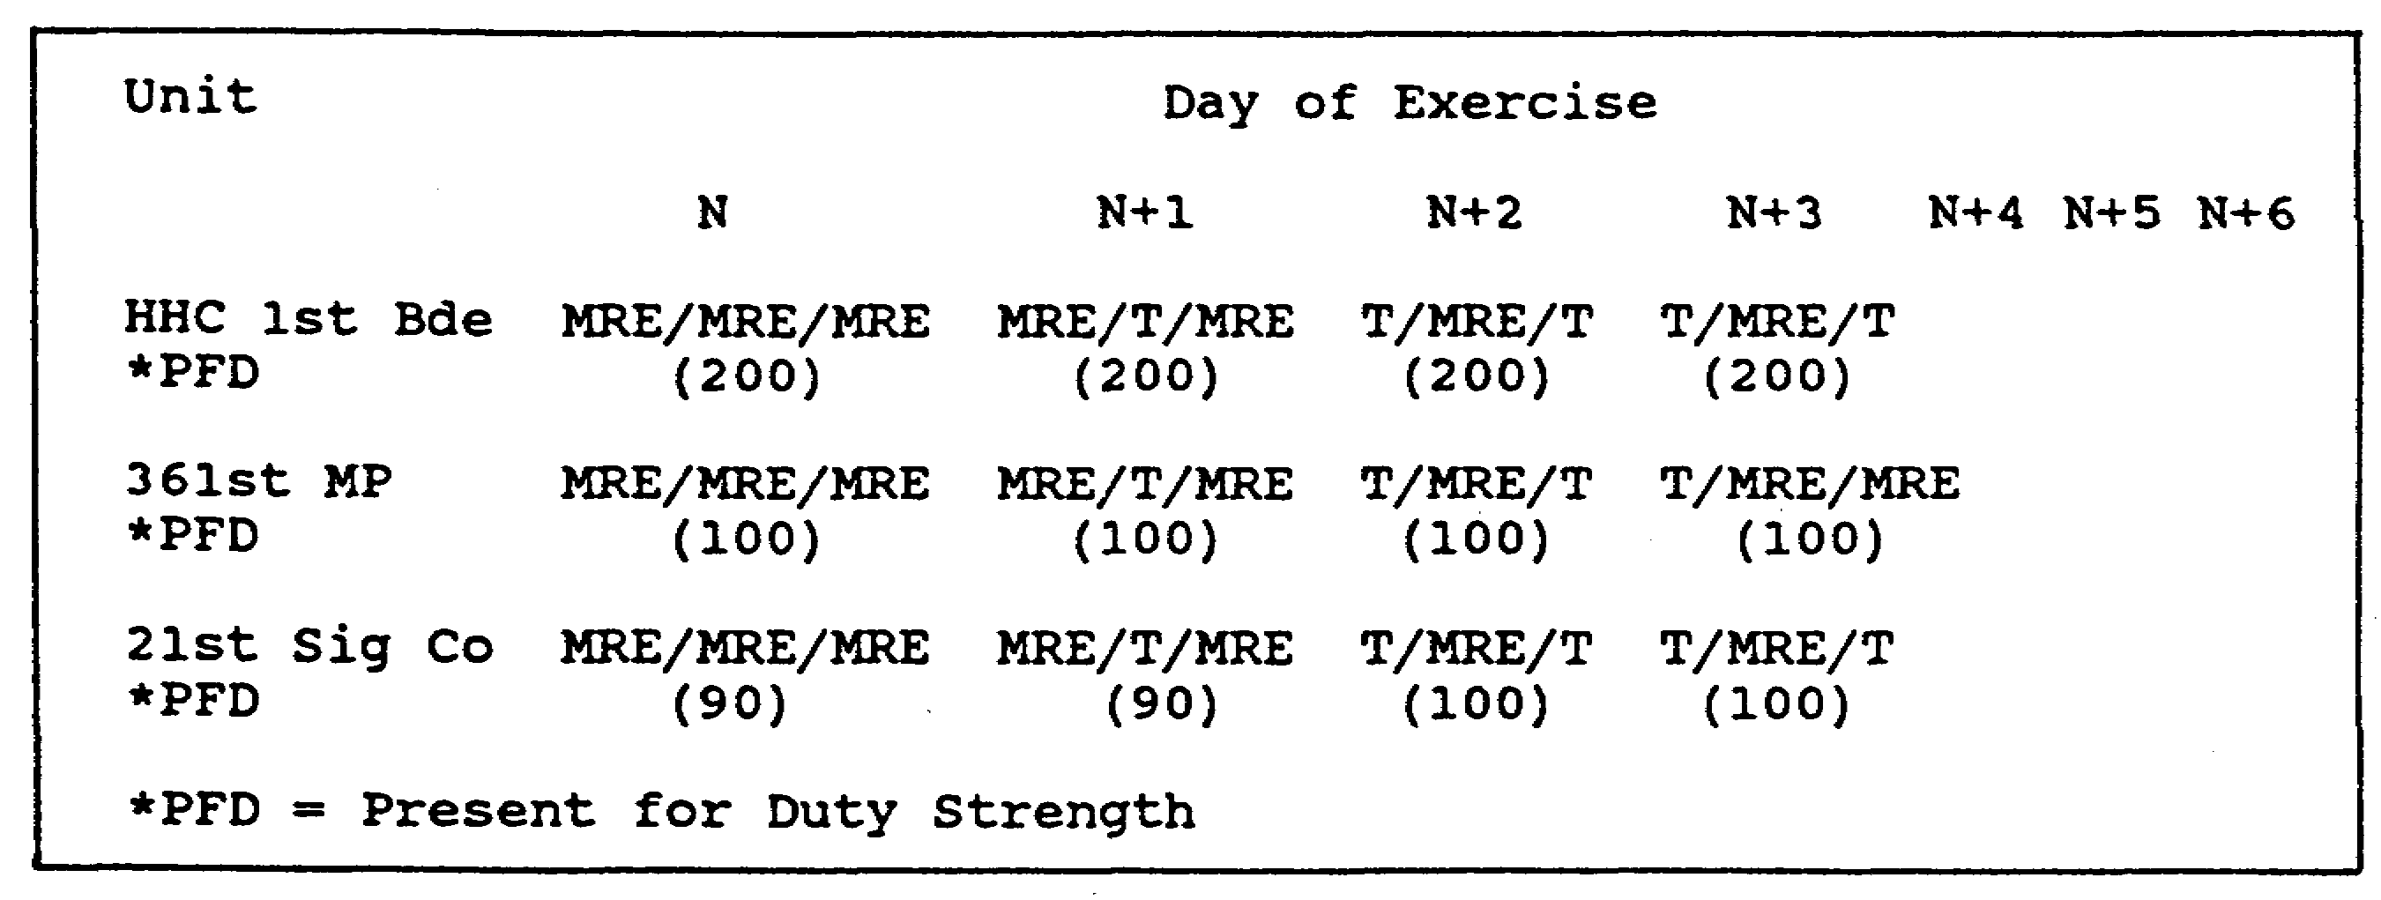

Figure 2. Sample Class I Spreadsheet.

(4) Supplements and Enhancements for T Rations. The T Ration must be supplemented by bread and milk to make the meal nutritionally complete. One-half pint of milk and 2.5 ounces (two slices) of bread are authorized per soldier per T Ration meal. Fresh, hardy fruit, like apples and oranges, can be issued with every T Ration meal. Dry cereal (bowl packs or boxes) can also be added to a T Ration meal. When dry cereal is issued for breakfast, an additional half pint of milk is authorized. In addition, fresh garden salad with individual dressings, spices, and condiments are now authorized. Menu boards or field training planning meetings are the best way to establish the amounts of authorized supplemental and enhancement items. Figure 3 shows the authorized food items and their maximum issue quantities; for example, under the fruit category, 35 pounds of apples per 100 soldiers are authorized; under salad items: tossed-green salad, 6 pounds of iceberg lettuce per 100 soldiers are authorized.

17 QM3853

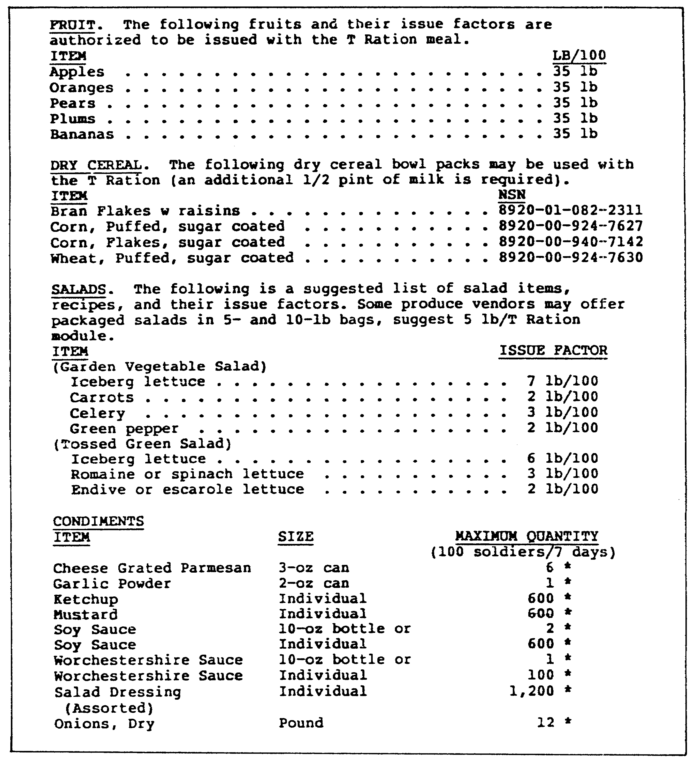

Figure 3. Authorized Items and Issue Quantities.

(5) Warming or Cooling Beverages. Consider any requirements that may involve using warming or cooling beverages,

18 QM3853

which are used in addition to the daily authorized beverage allowances found in the field menu. Warming and cooling beverage allowances can be used for guards or 24-hour shift personnel. This allowance requires clearance from the installation food advisor; it is not automatic and must be an integral part of your deployment plan.

(6) Substitutions and Deletions. Changes to the prescribed menu are inevitable. However, through effective deployment Class I planning, you can keep substitutions and deletions to a minimum. It is also a good idea to notify commanders, FSSs, and cooks of any authorized scheduled substitutions or deletions. The Troop Issue Subsistence Officer (TISO) and/or Class I officer is the best place to get this type of information.

d. Class I Distribution and Accounting System. It is necessary to understand thoroughly the Class I distribution and accounting system established for your unit's exercise or deployment. Other issues to consider include Class I supply point locations, the issue schedule, the distribution method (unit or item pile), and Class I issue times (day or night). The type of Class I distribution system is determined 30, 60, and 90 days before the exercise start date.

(1) Division Request Procedures. Figure 4 shows the request and distribution scheme for an infantry division, which consists of the following actions (in order).

o The unit provides present strength for duty and remote site information.

o The feeder unit requests Class I items from the main or forward direct support unit (DSU).

o The main or forward DSU submits requests for consolidated form.

o Division material management center (DMMC) sends requisitions for needed items.

o COSCOM material management center sends a material release order directing the general support unit (GSU) to ship rations.

o GSU ships rations with a transportation and movement document (TCMD).

o DSU issues rations to the unit, forward supply point, or logistics release point.

19 QM3853

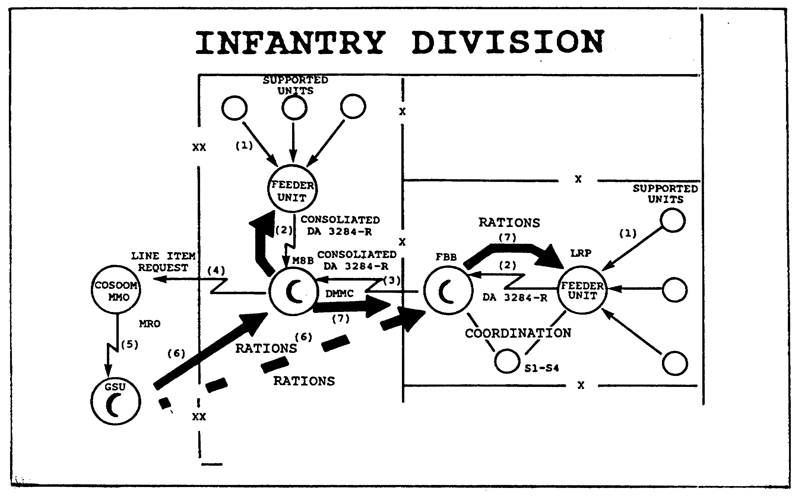

Figure 4. Request and Issue Procedures in the Division.

(2) Predeployment Planning Documents. The key personnel who decide how the system operates are the corps support command (COSCOM) or division support command (DISCOM) commander, supply and services or the supply and transportation commander, the Assistant Chief of Staff, (Logistics) (G4) or Supply Officer (Army) (S4), the Class I officer, and the food advisor. Specifics of the Class I distribution system for your predeployment planning are also available from various documents in your unit. These include the following.

o Combat service support annex of the operations order or operations plan.

o Combat service support overlay prepared by logistics planners from the G4, S4, and COSCOM or DISCOM.

o Field exercise letter of instruction.

o External support plan prepared by the Class I section of the COSCOM or DISCOM.

20 QM3853

e. Other Planning Requirements. It is important to include some additional aspects of the exercise. You must plan for water, fuel, ice, waste disposal, and residuals (leftover food items) before you arrive in the exercise area.

(1) Location. The grid coordinates for the water, fuel, and trash points are just as important as the location of Class I supply points. In many instances, fuel, water, and ice are distributed to the supply point. However, each field exercise deployment differs, so you must know the grid coordinates for each supply source.

(2) Disposal. Disposition of residuals also must be an integral part of the deployment planning process. Before leaving for the field, know which residuals can or cannot be turned in to the supply point. Knowing the disposition instructions of leftover usable food items is especially crucial when participating in overseas deployments.

f. Checklist. Class I and food service predeployment planning is necessary for successful mission accomplishment. Although all the planning information discussed here is available in your unit, in many instances it does not get into the operator's hands. Use the planning checklist in Figure 5 to determine whether or not you have been given all the information necessary for a successful Class I and food service mission.

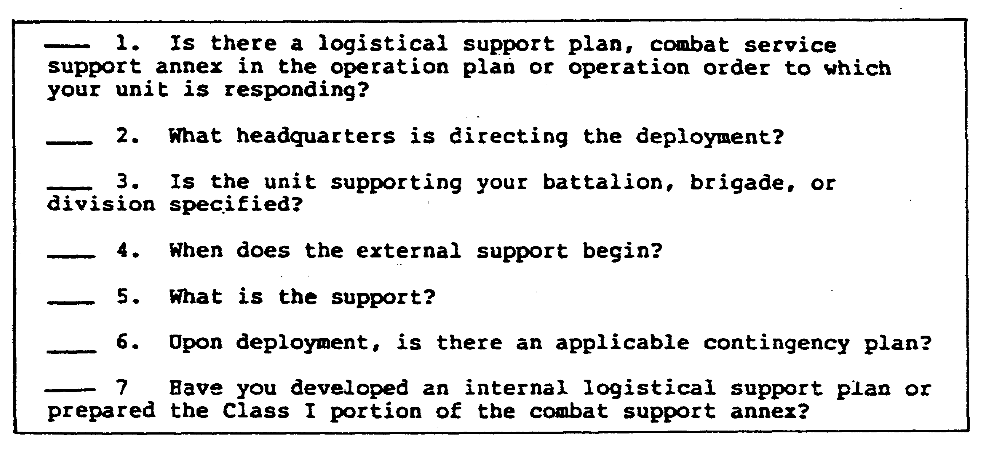

Figure 5. Predeployment Planning Checklist.

21 QM3853

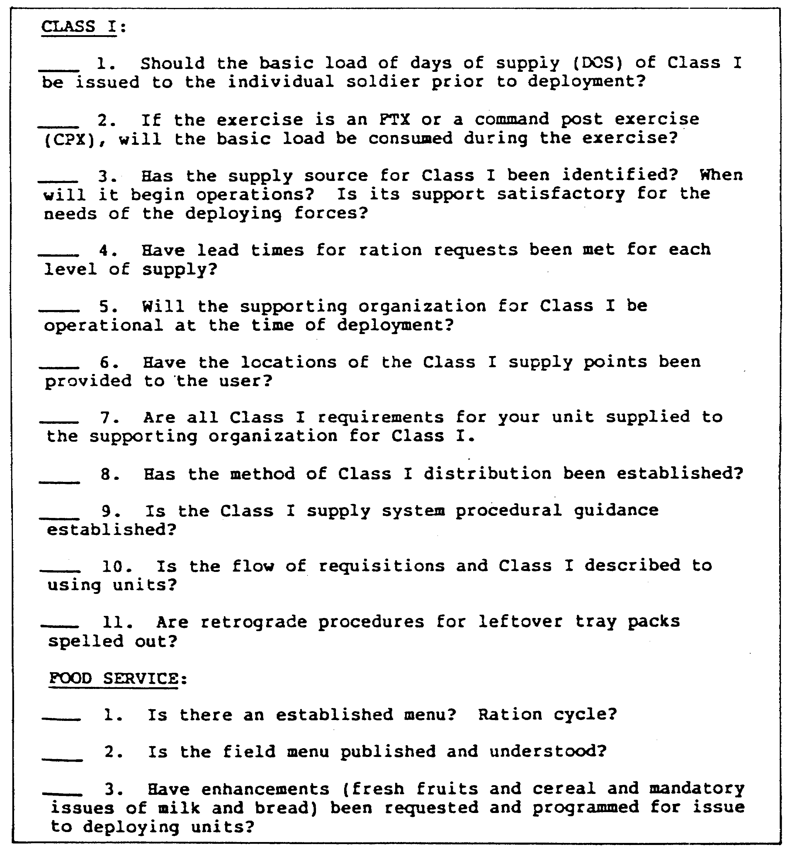

Figure 5. Predeployment Planning Checklist (continued).

22 QM3853

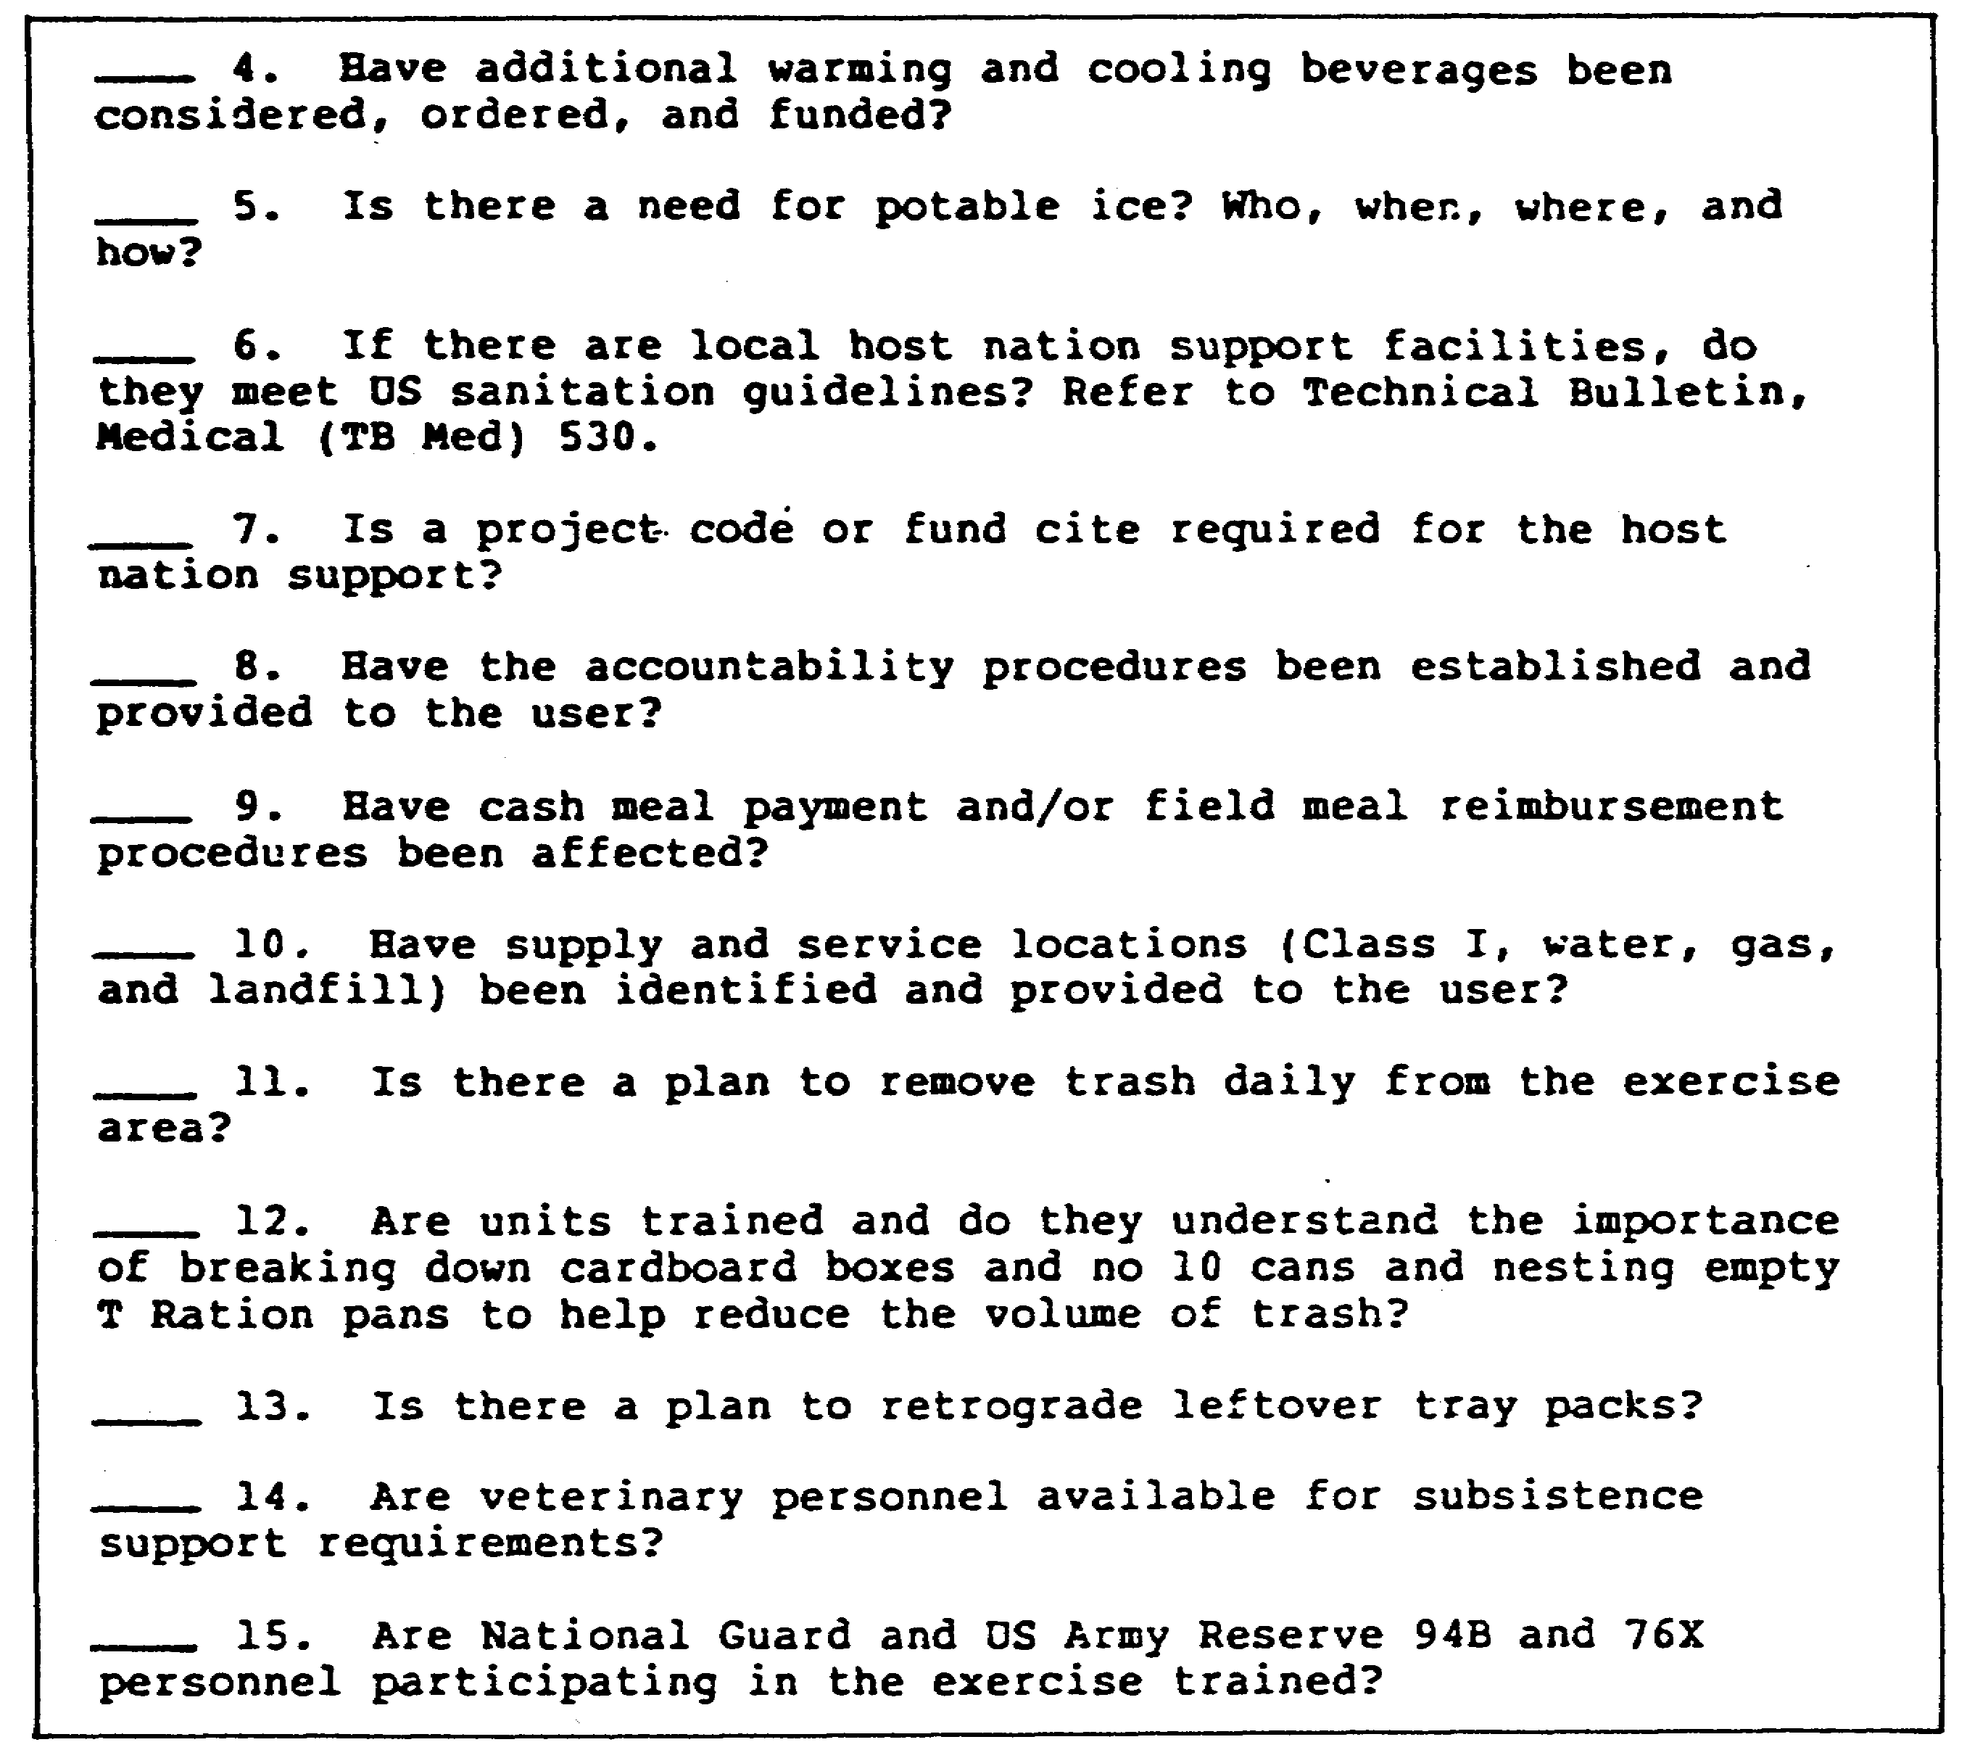

Figure 5. Predeployment Planning Checklist (continued).

4. Deployment Techniques.

This section outlines deployment techniques and factors for successfully accomplishing the field food service mission. Changes to field feeding doctrine are also outlined for both heavy and light EAD forces. Specific deployment factors discussed consist of the following.

o Unit movement to the deployment site including ground and air movement, overnight stops, rest halts, railheads, and alert holding areas.

23 QM3853

o Site selection, layout (rear area), and camouflage.

o Field feeding procedures including AFFS concept changes; feeding doctrine (light forces, heavy forces, and EAD); remote site feeding; and logistics package concept.

o Accountability.

o AFFS capabilities and characteristics.

a. Unit Movement. Unit movement to the deployment site may take as little as one hour or may involve days or weeks of travel. The unit movement control officer and the division or corps transportation officer prepare the unit movement plan. They are a good source for detailed information on when units are to deploy, how they will deploy (air or ground), unit movement timetables, and convoy routes. Movement information is vital because of the varied food service requirements from your home station until your unit arrives at the deployment location. In addition to feeding soldiers three meals per day, be sure warming and cooling beverages are prepared for convoy rest halts, railheads, and alert holding areas.

b. Field Kitchen Site Selection. Once your unit arrives at the deployment location, immediately determine the best available site for the field kitchen operation. The unit commander or food service officer (FSO) specifies the general location.' However, since you are the technical expert, you must consider the characteristics of a good field site. These are stated in Figure 6.

c. Field Kitchen Site Layout (Rear Area). After the field kitchen site selection, the layout must be determined for your field kitchen operation. Figure 7 shows where to place the different facilities required to operate the rear area field kitchen operation, as well as the characteristics for site selection and the access from the bivouac area to the dining area. Also shown are the locations of the water-sterilizing bags, latrine, hand-washing devices, lighting area, ration storage, gasoline storage, and refueling area. You must camouflage the field kitchen area to keep enemy aircraft, ground forces, or infrared sensors from finding you.

5. Coordination of Hospital Subsistence Requirements With the Field Medical Facility.

Ration request and issue procedures for field medical facilities are the same as those procedures previously explained in this Part of the lesson. However, medical facilities may request special items to fulfill the unique nature of their mission.

24 QM3853

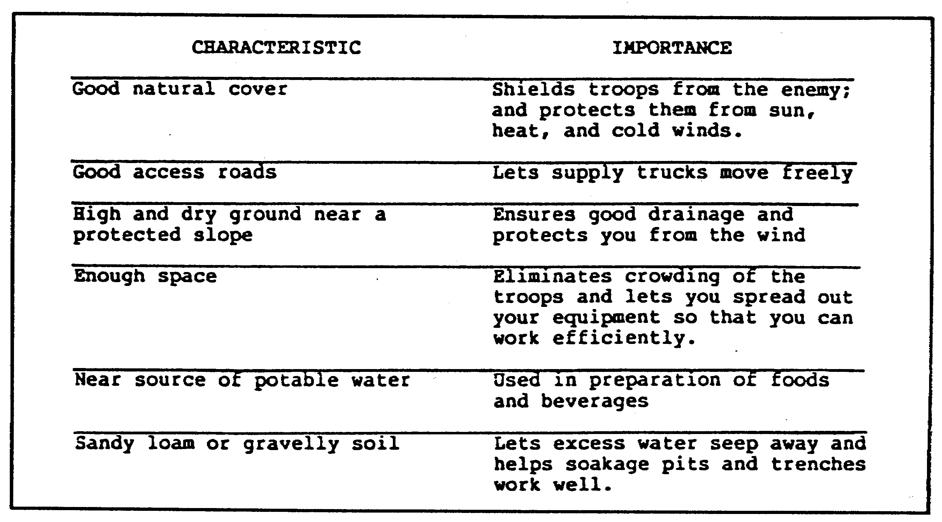

Figure 6. Characteristics of a Good Field Site.

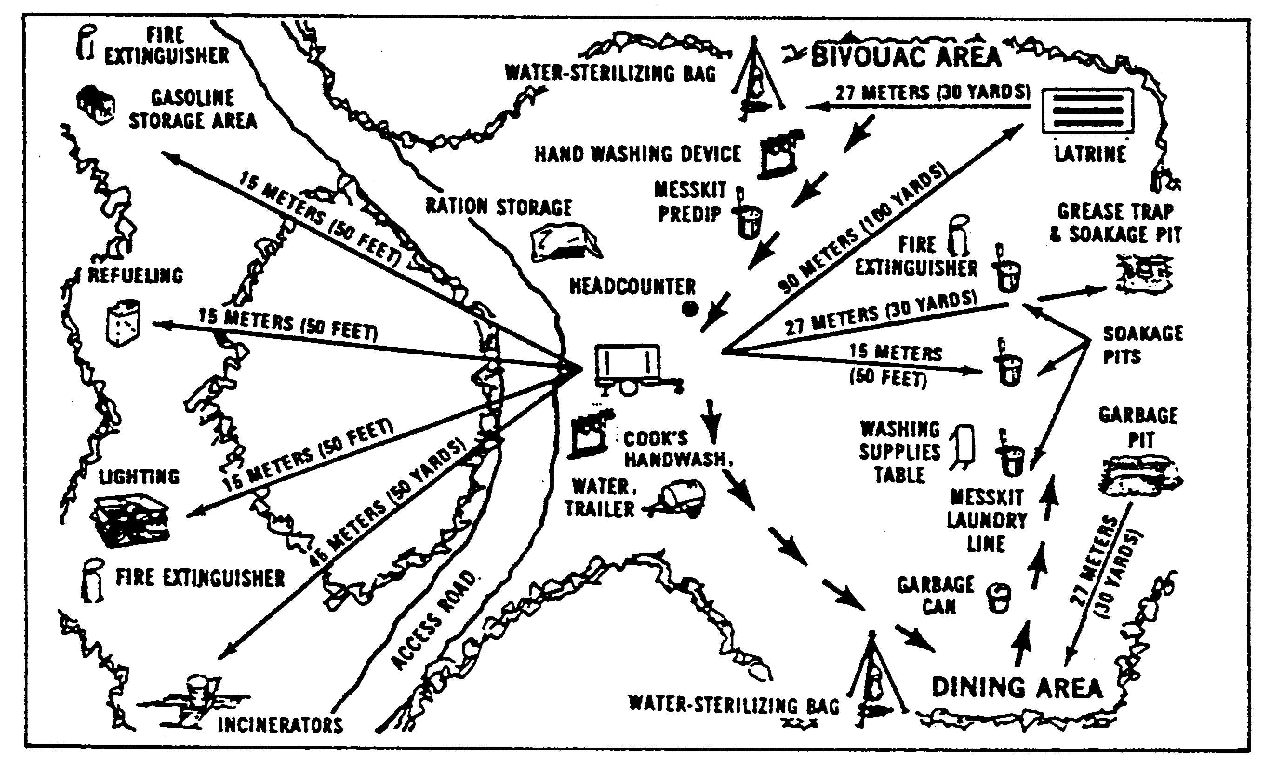

Figure 7. Field Kitchen Site Layout (Rear Area).

25 QM3853

6. Field Kitchen Modular (FKM) and Sanitation Center.

The FKM and sanitation center provide the responsiveness, flexibility, and mobility needed to meet the feeding requirements of medical units in the field. The FKM is issued to field hospital units and is designed to support up to 300 troops with two hot A, B, or T Ration meals per day if refrigerated storage is available. FKMs can be consolidated to form larger field hospital kitchens with multiple serving lines to support larger numbers of troops. It is a collection of field kitchen equipment housed in a temper, which provides wet protection with door coverings, windows, roof vents, and a tent fly. The sanitation center consists of equipment required to clean and sanitize food service equipment, patient and staff eating utensils, and trays. One sanitation center is issued to each FKM. Figure 8 is a field kitchen modular. Figure 9 is a labeled diagram of a temper.

a. Configuration of FKM, Sanitation Center and Dining Area. One of the best features of the AFFS is its flexibility; the variations are almost unlimited. The FKM, the sanitation center, and the dining area can be set up separately with or without vestibules and vestibule doors (depending on the region), or they can be combined into varying configurations. For convenience, it may be desirable to attach the FKM and the sanitation center by a vestibule. Then, it is not necessary to go any distance to take pots and utensils to the sanitation center, which speeds up the entire operation. The preparation, serving, and dining areas can be configured into one large area by attaching two tempers with or without vestibules. Figure 10 shows a vestibule section laced to a vestibule adapter.

In cold regions, air exchange can be reduced to a minimum by connecting the sanitation center, the FKM, and even a dining temper by vestibules. The tent entrances, especially in cold regions, should have a vestibule with a door attached to cut down on air exchange. Figure 11 shows tempers connected by vestibules.

FKM major equipment items can be arranged to provide preparation areas, cooking areas, ration storage areas, serving lines, and even a dining tent. FKM equipment is transported by a 5-ton truck with a 1 1/2 ton trailer.

26 QM3853

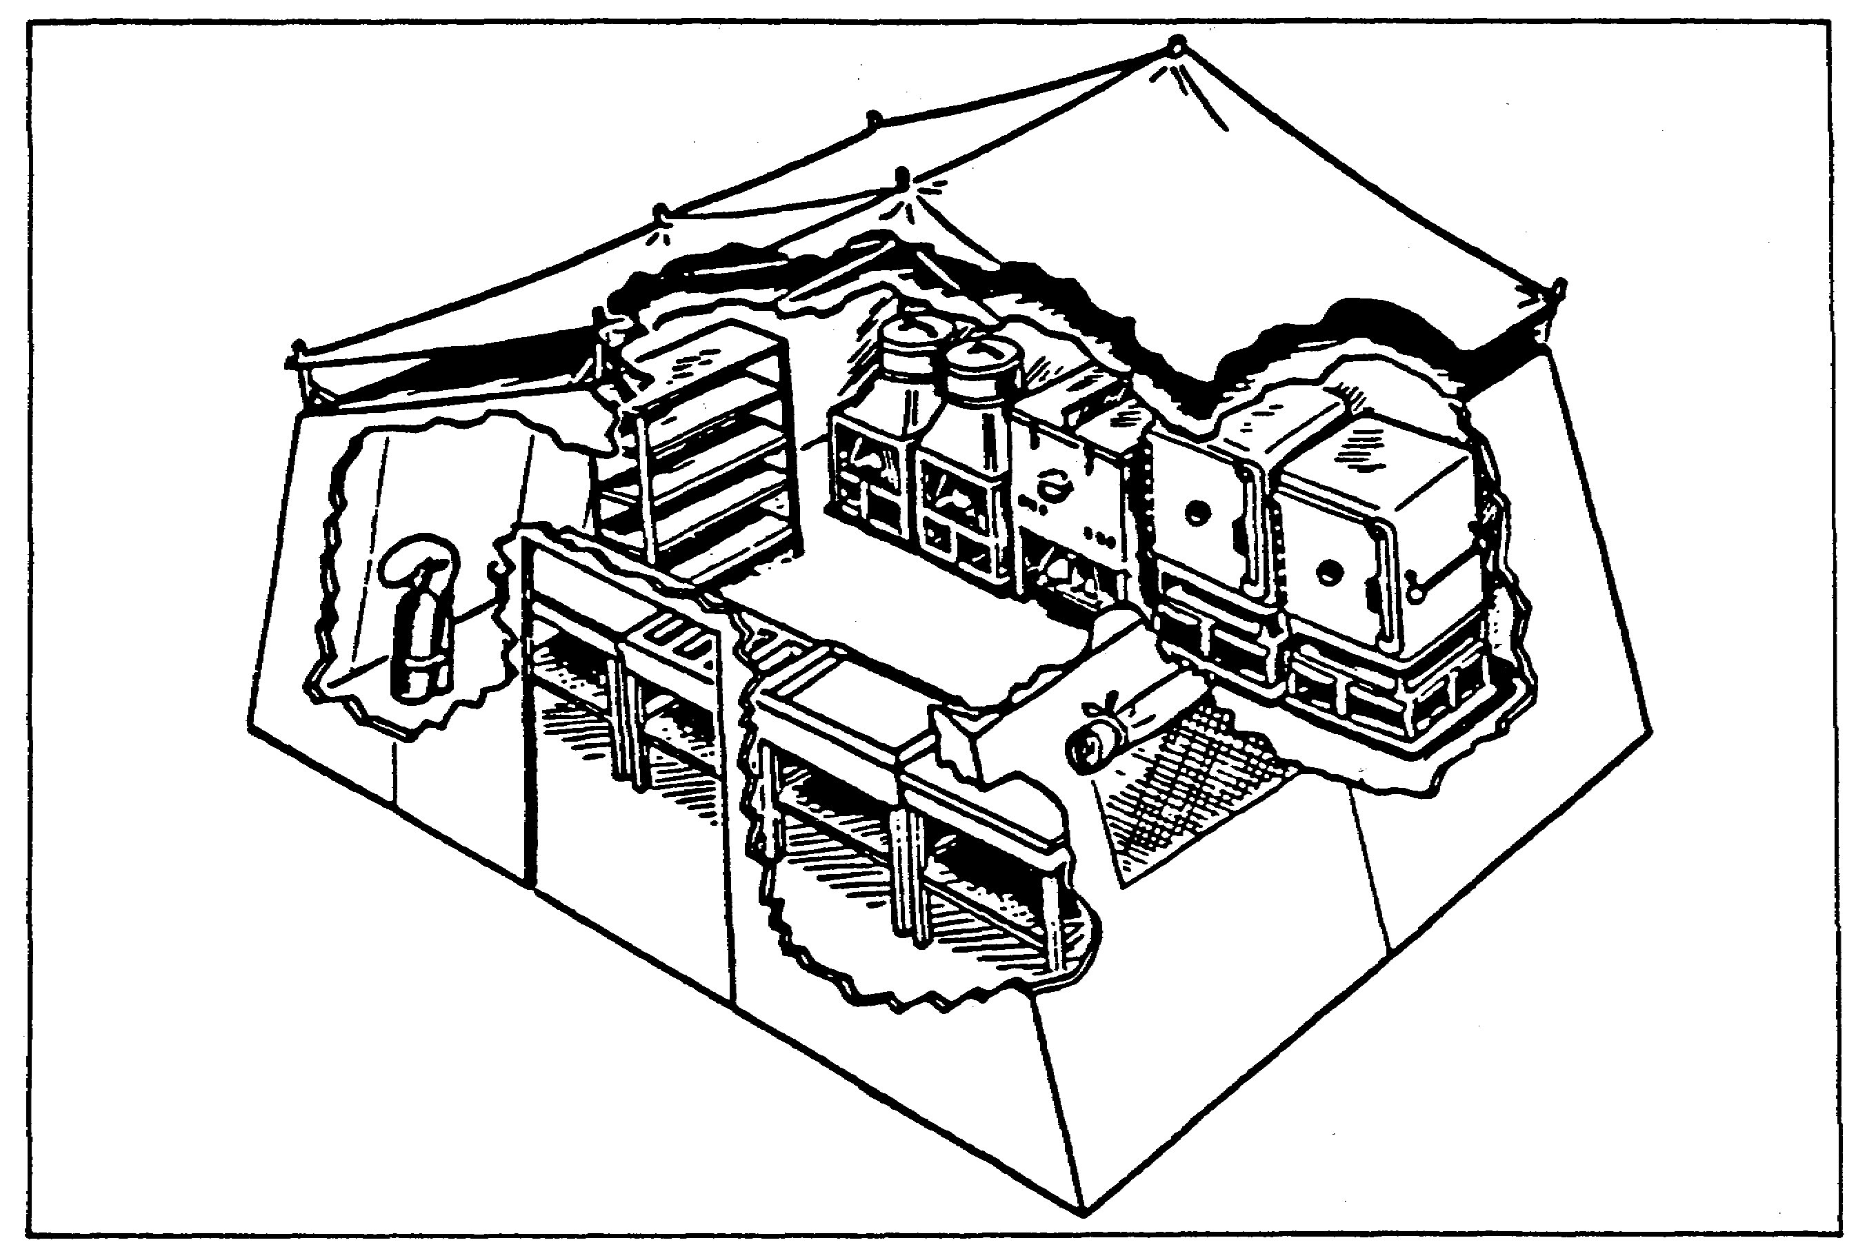

Figure 8. Field Kitchen Modular.

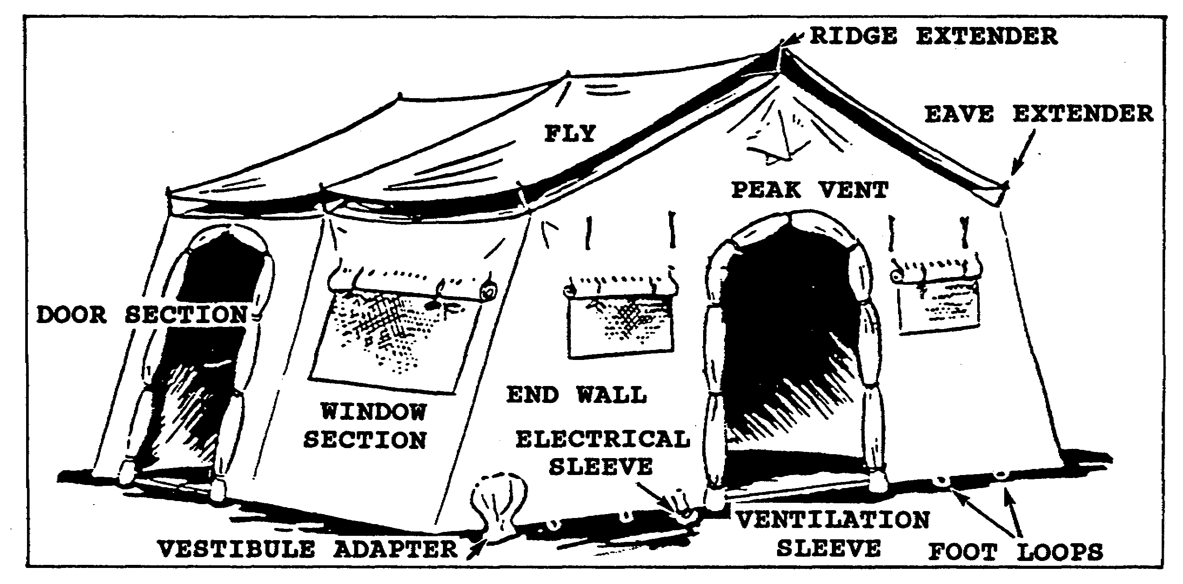

Figure 9. Temper.

27 QM3853

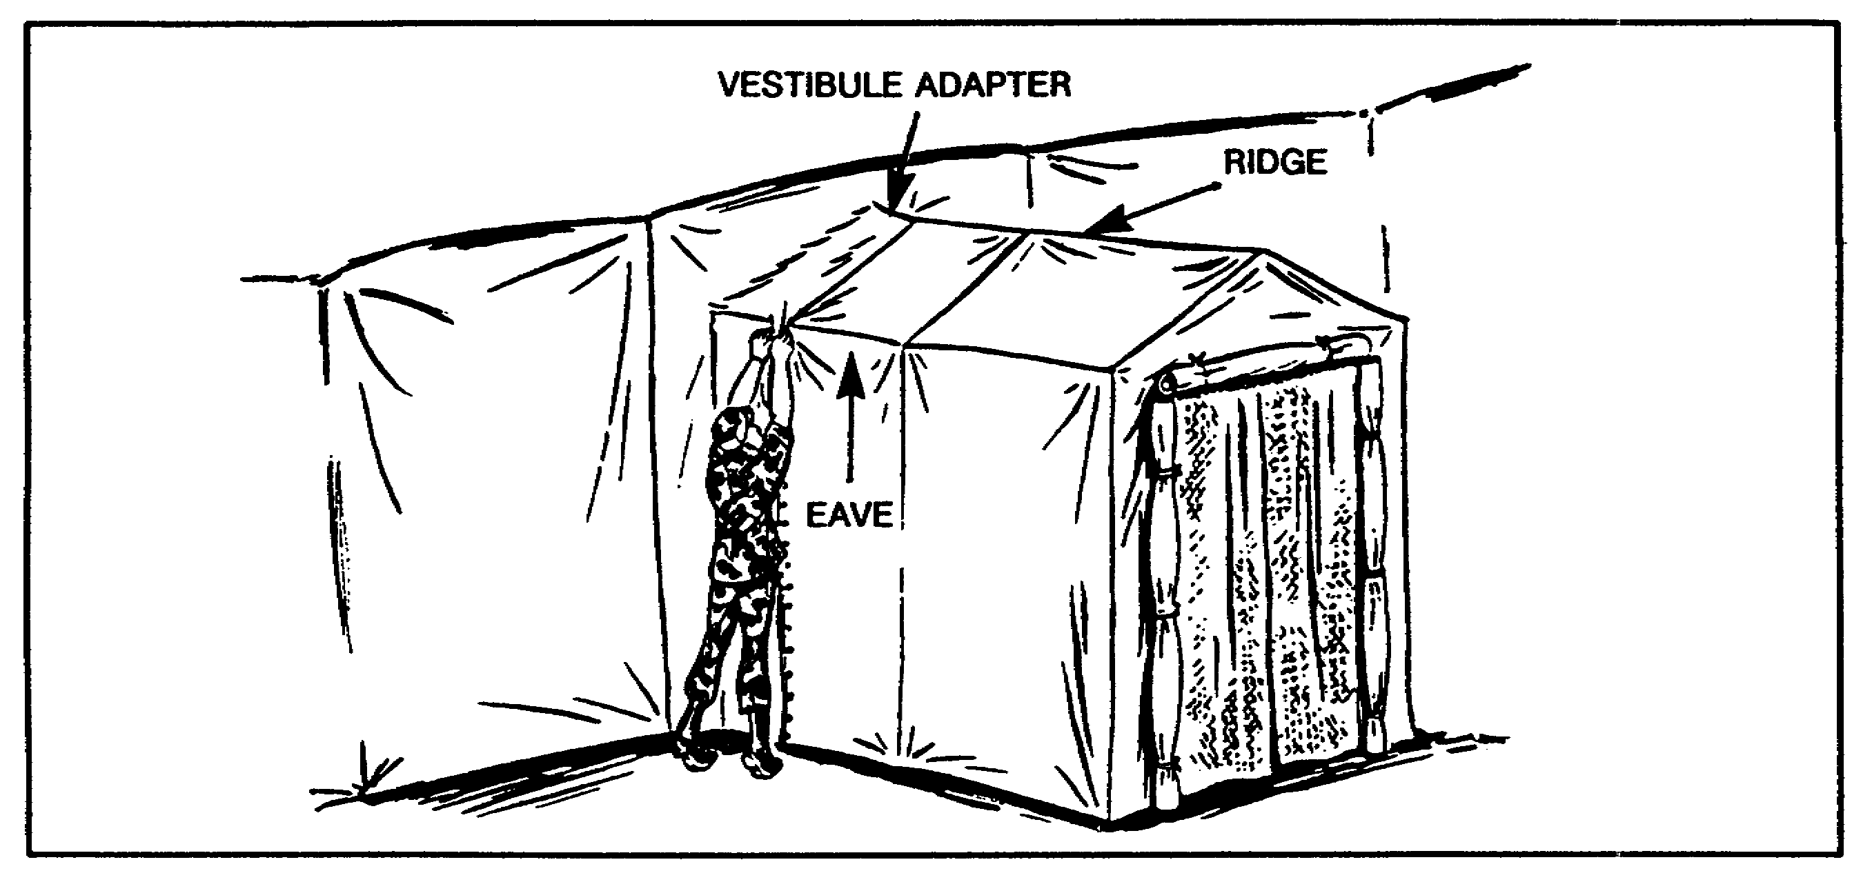

Figure 10. Vestibule Section Laced to Adaptor.

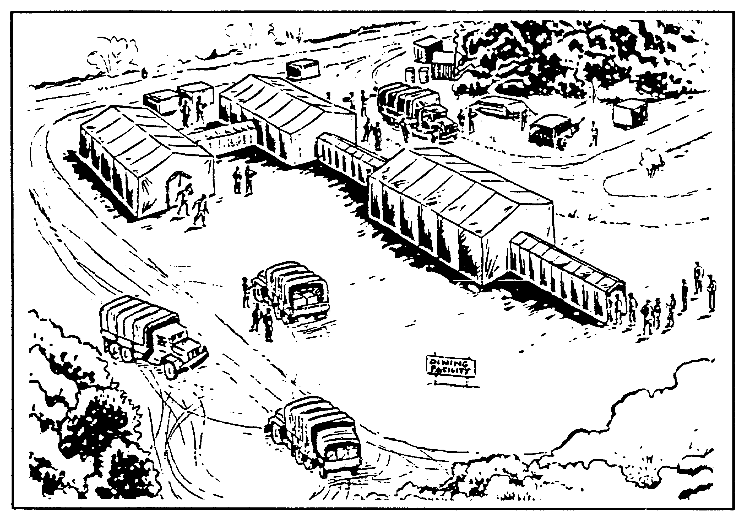

Figure 11. Tempers Connected by Vestibules.

28 QM3853

b. Components. Basic items of issue for the FKM are as follows.

(1) Griddle, Oven and Pot Cradle. The griddle (Figure 12), the oven (Figure 13), and the pot cradle assembly (Figure 14), with M2 burners, are provided for roasting, baking, boiling, grilling, and maintaining serving temperatures of hot food.

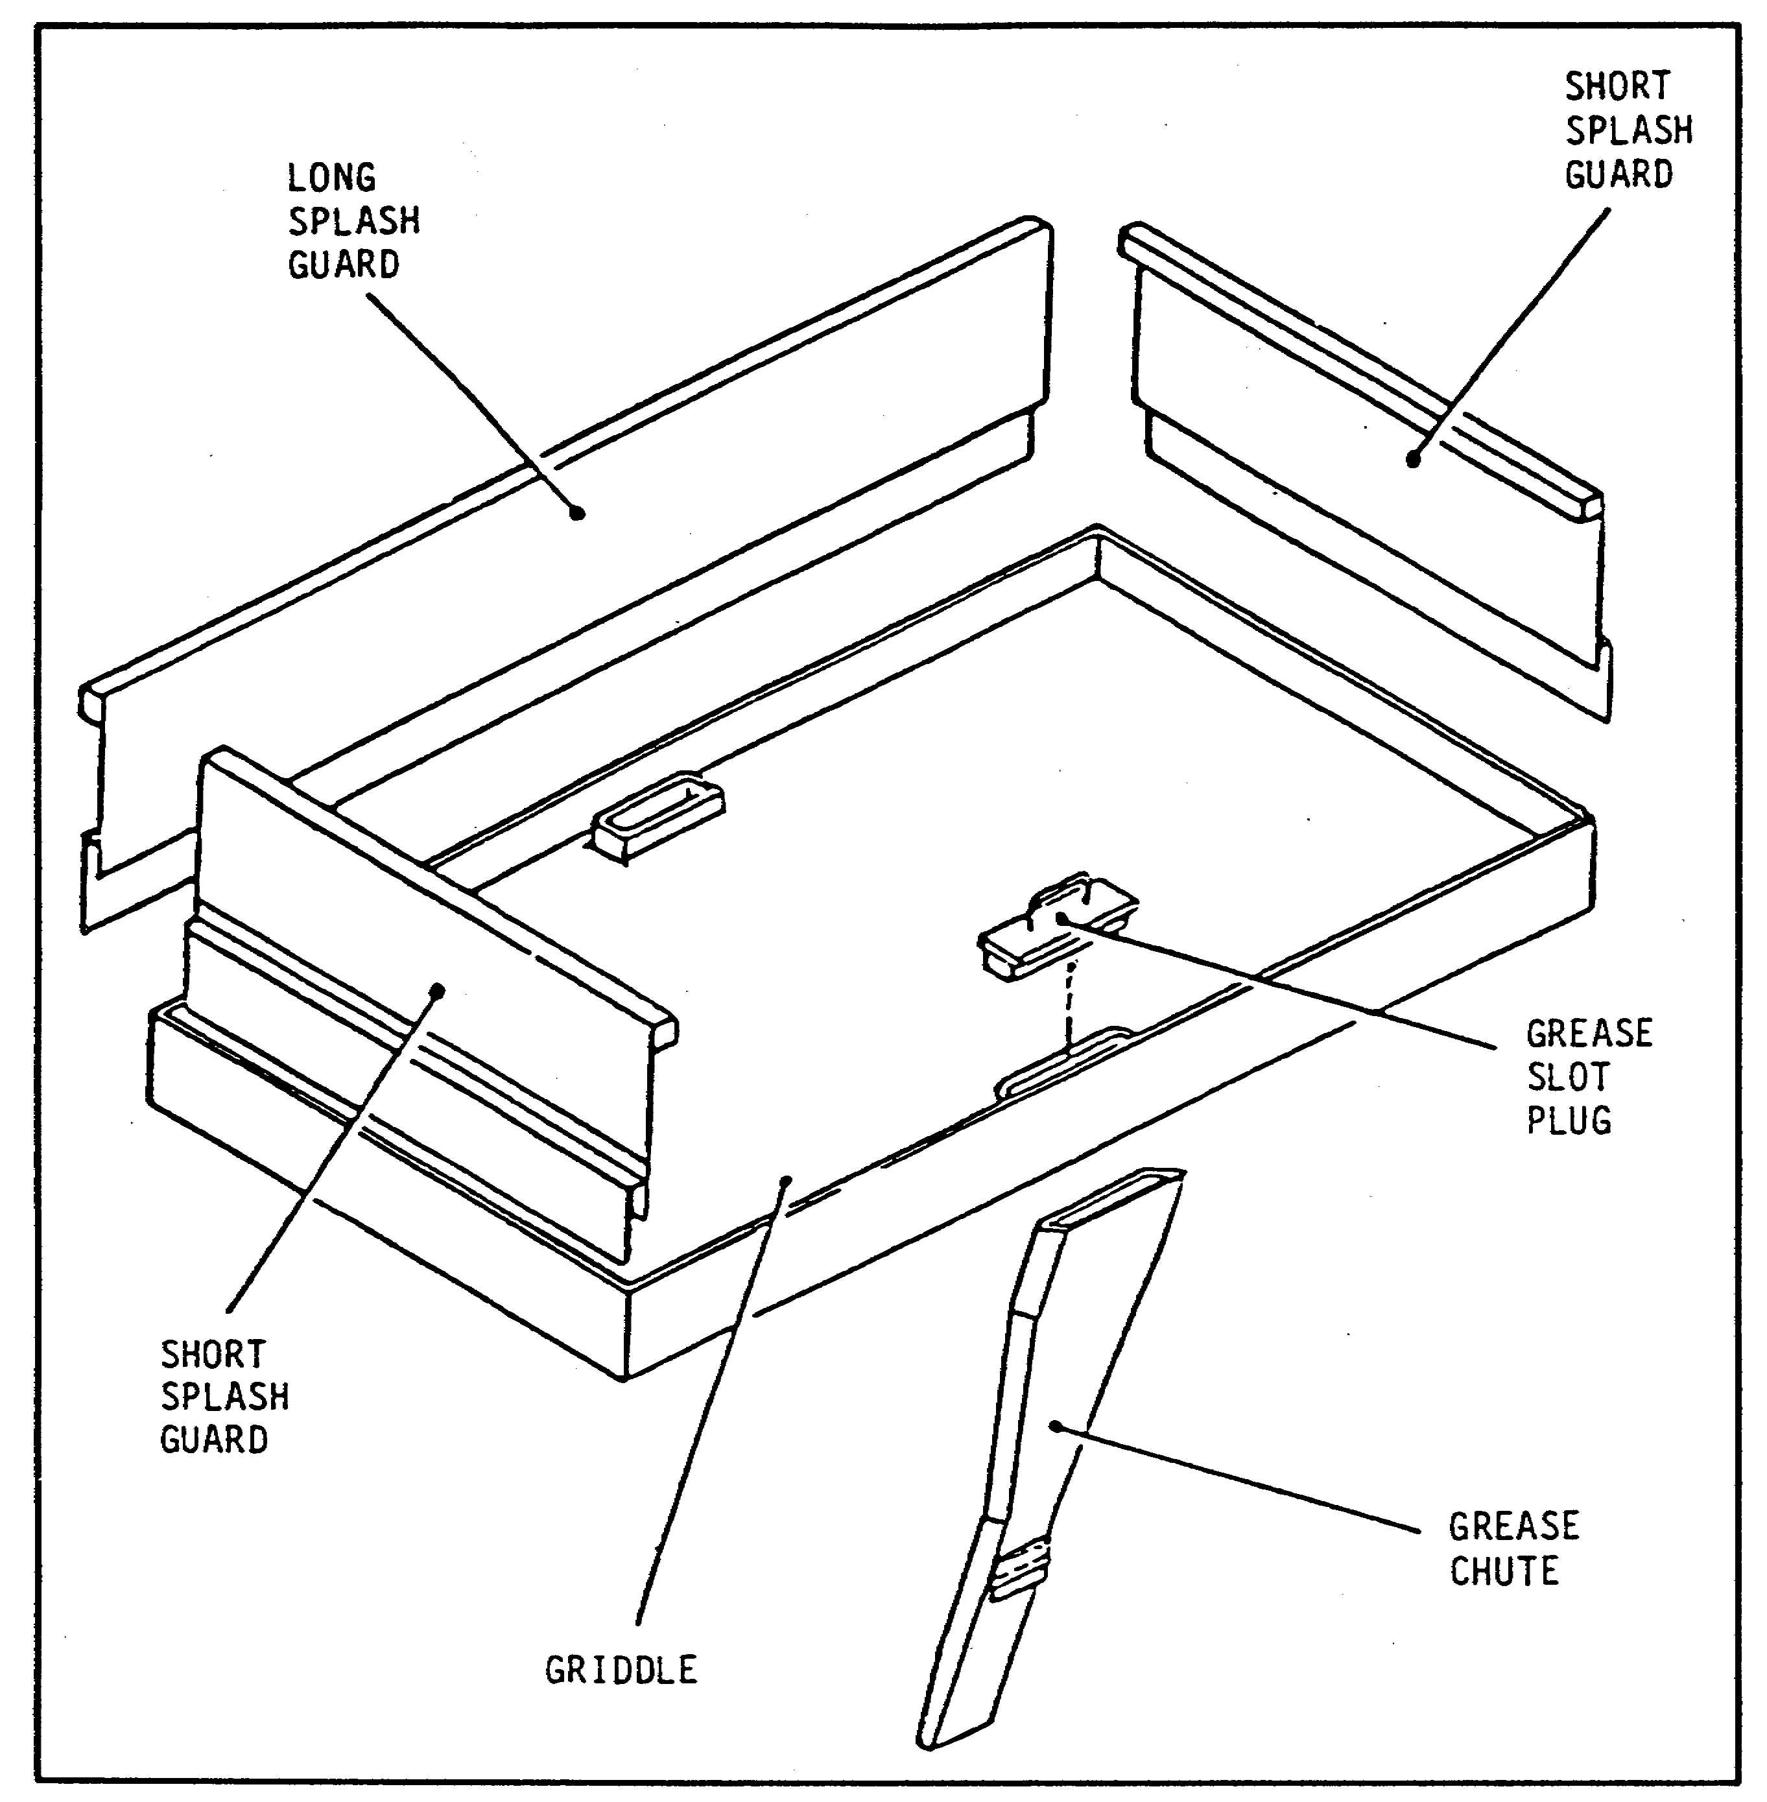

Figure 12. Griddle Top Assembly.

29 QM3853

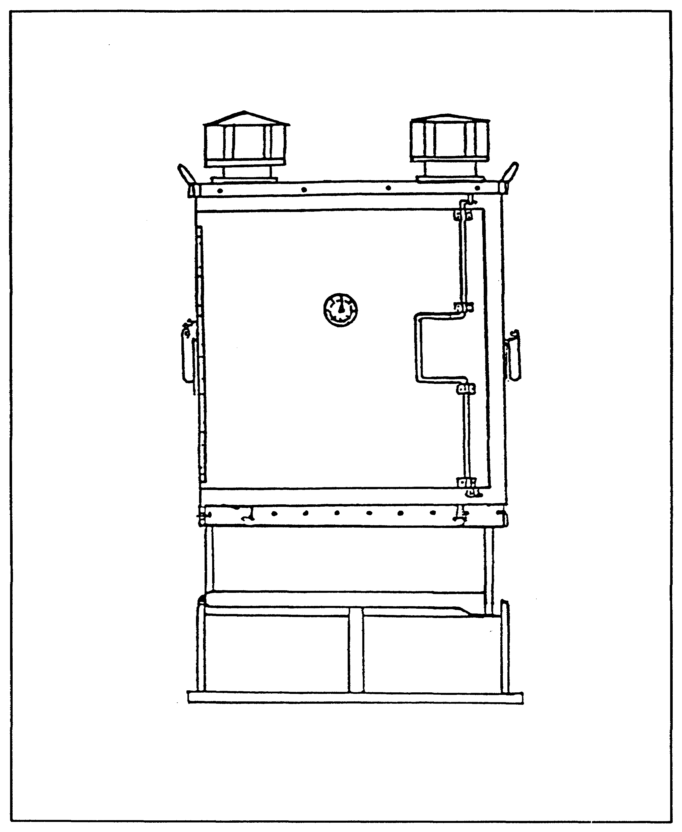

Figure 13. Oven Assembly.

30 QM3853

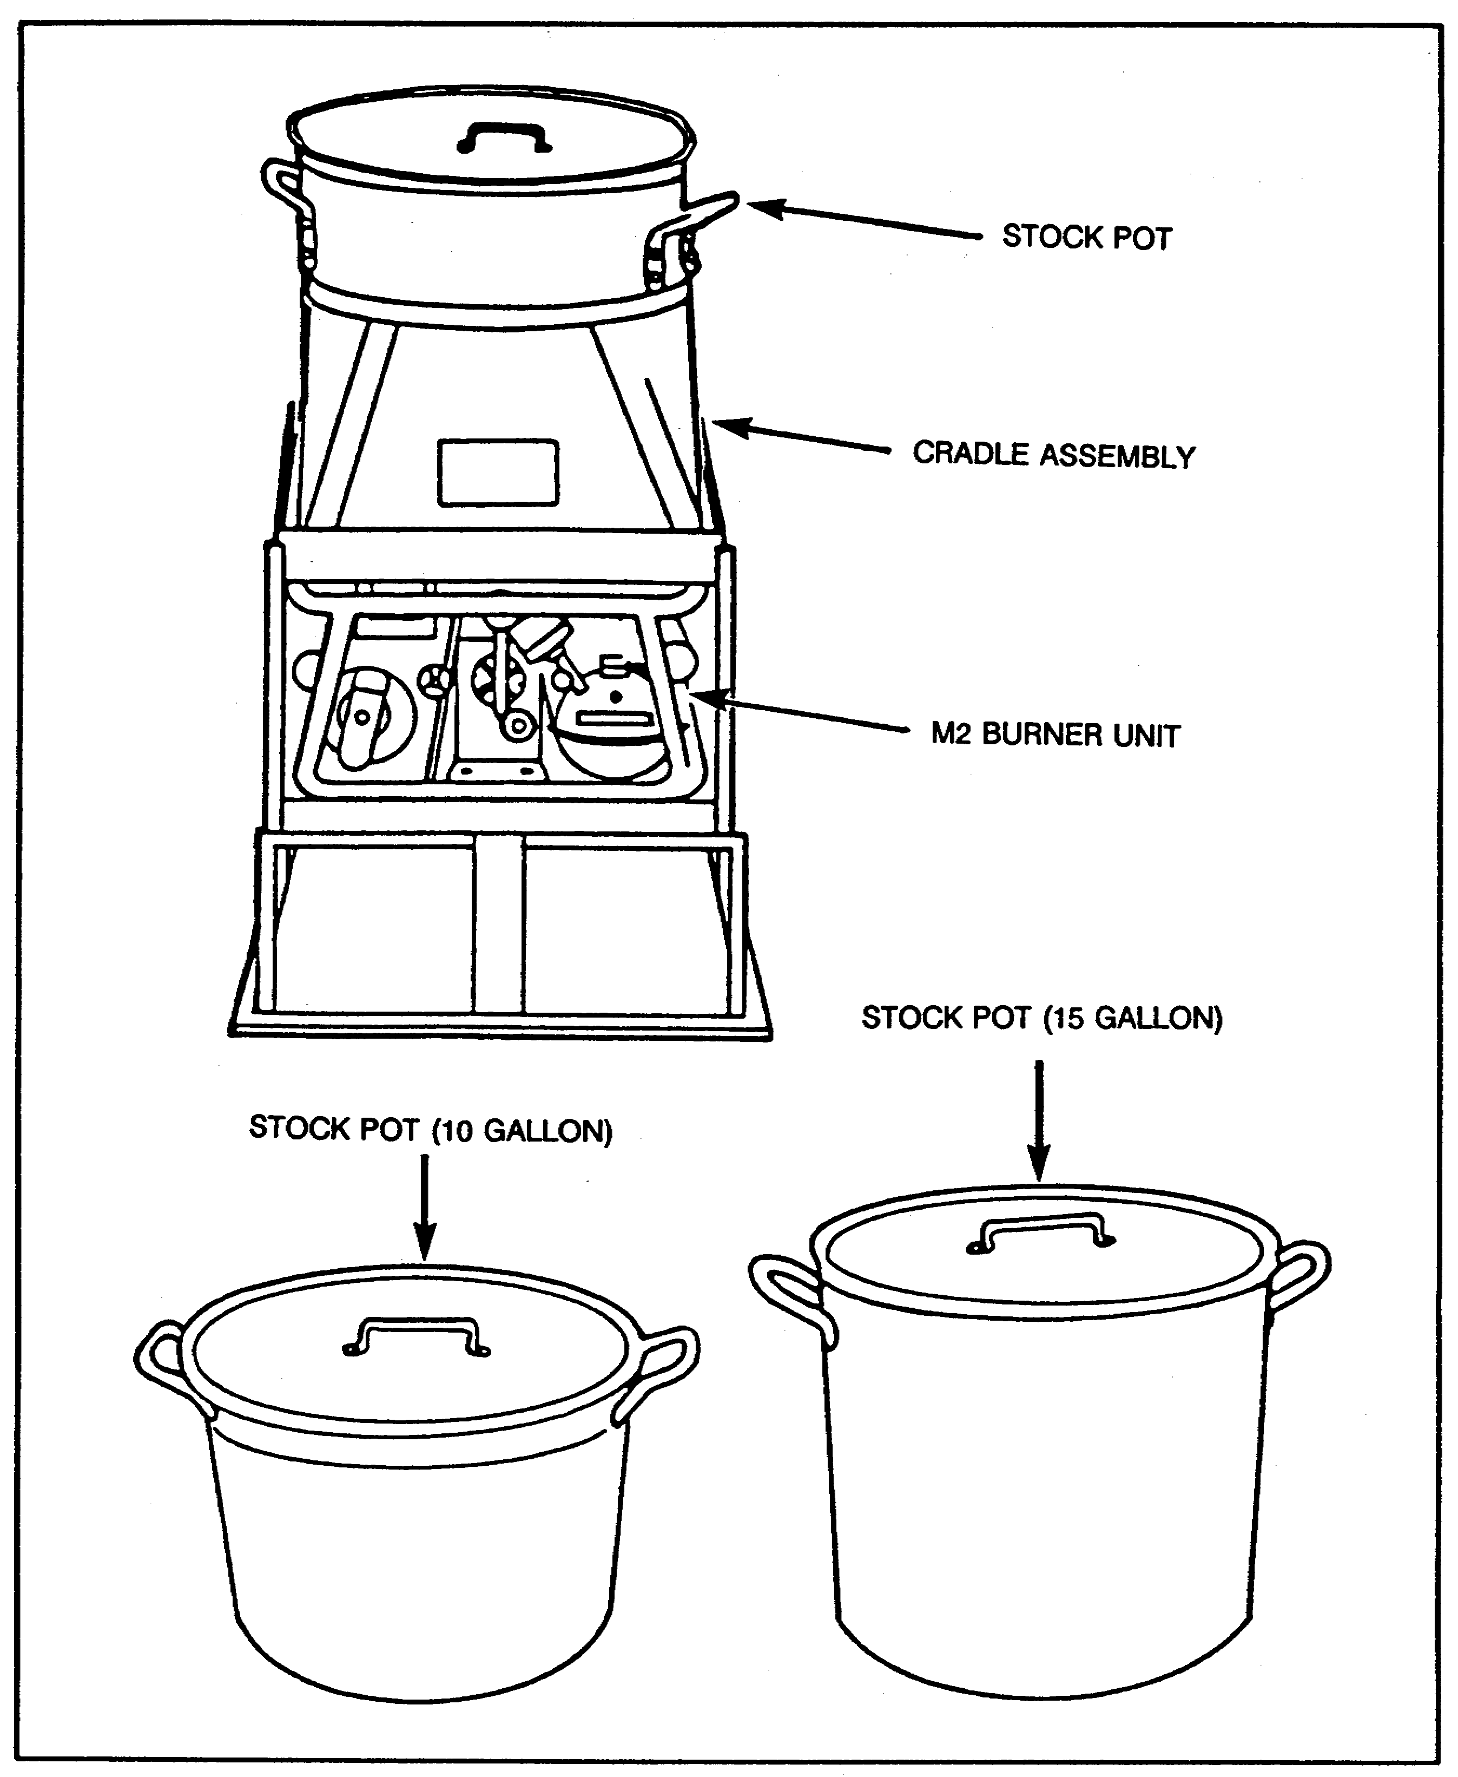

Figure 14. Pot Cradle Assembly and Stock Pots.

31 QM3853

(2) Steam Table. The steam table (Figure 15), with M2 burner, is used to keep hot foods hot on the serving line throughout the serving period.

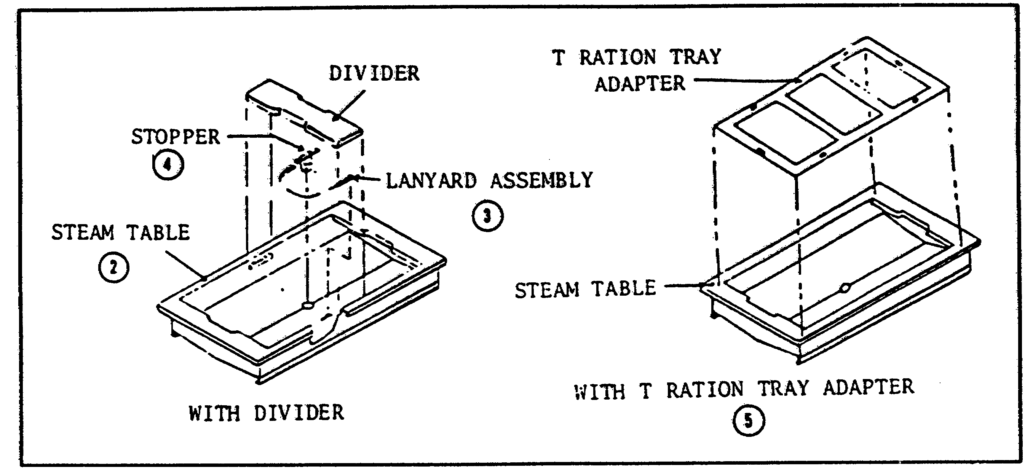

Figure 15. Steam Table Top Assembly, Knock-down, and Field.

(3) Steam Table Adapters. The FKM comes with three adapters to aid serving procedures. There are one-hole, two-hole, and four-hole adapters. These adapters are used with baking and roasting pans, line pans, tray packs, and plastic inserts for serving. When the one-hole adapter is used with two baking and roasting pans, it is placed all the way to one end of the steam table. The two-hole adapter can be used with a baking and roasting pan, tray packs, plastic inserts, or line pans.

(4) Worktables, Serving Tables and Storage Racks. These tables are used for mixing, assembling, and chopping ingredients; serving line counter space; and cleaning pots and pans in the sanitation center. The storage rack can be used to transport and to store rations.

(5) Food Storage Cabinets. These cabinets are used mainly to store and to maintain pastries and desserts.

(6) Heater Cabinet. The heater cabinet (Figure 16), with the M2 burner in place and filled with water, heats up to 20 tray packs when submerged in the water.

(7) Meal Carriers and Insulated Food Containers. These carriers and containers hold hot foods and maintain serving temperatures before serving. Meal carriers are being replaced by

32 QM3853

insulated food containers as shown in Figure 17. Units may continue to use the meal carriers until they are no longer serviceable. At that time they are replaced with insulated food containers.

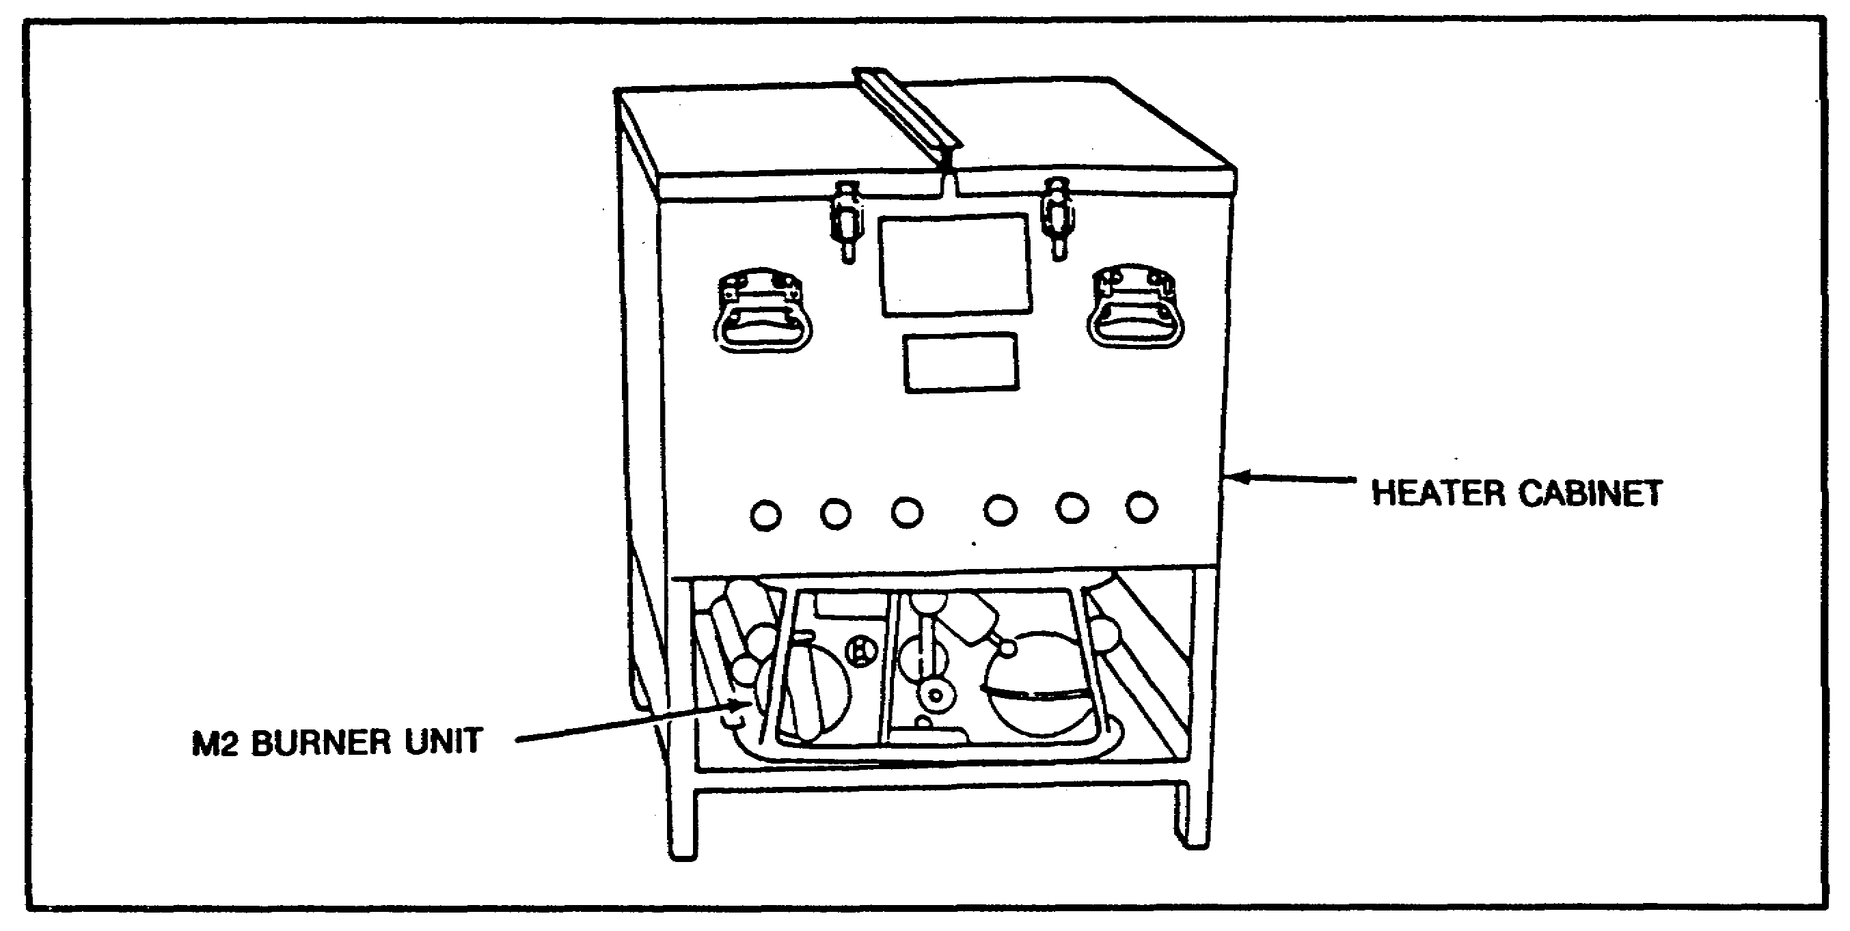

Figure 16. Heater Cabinet.

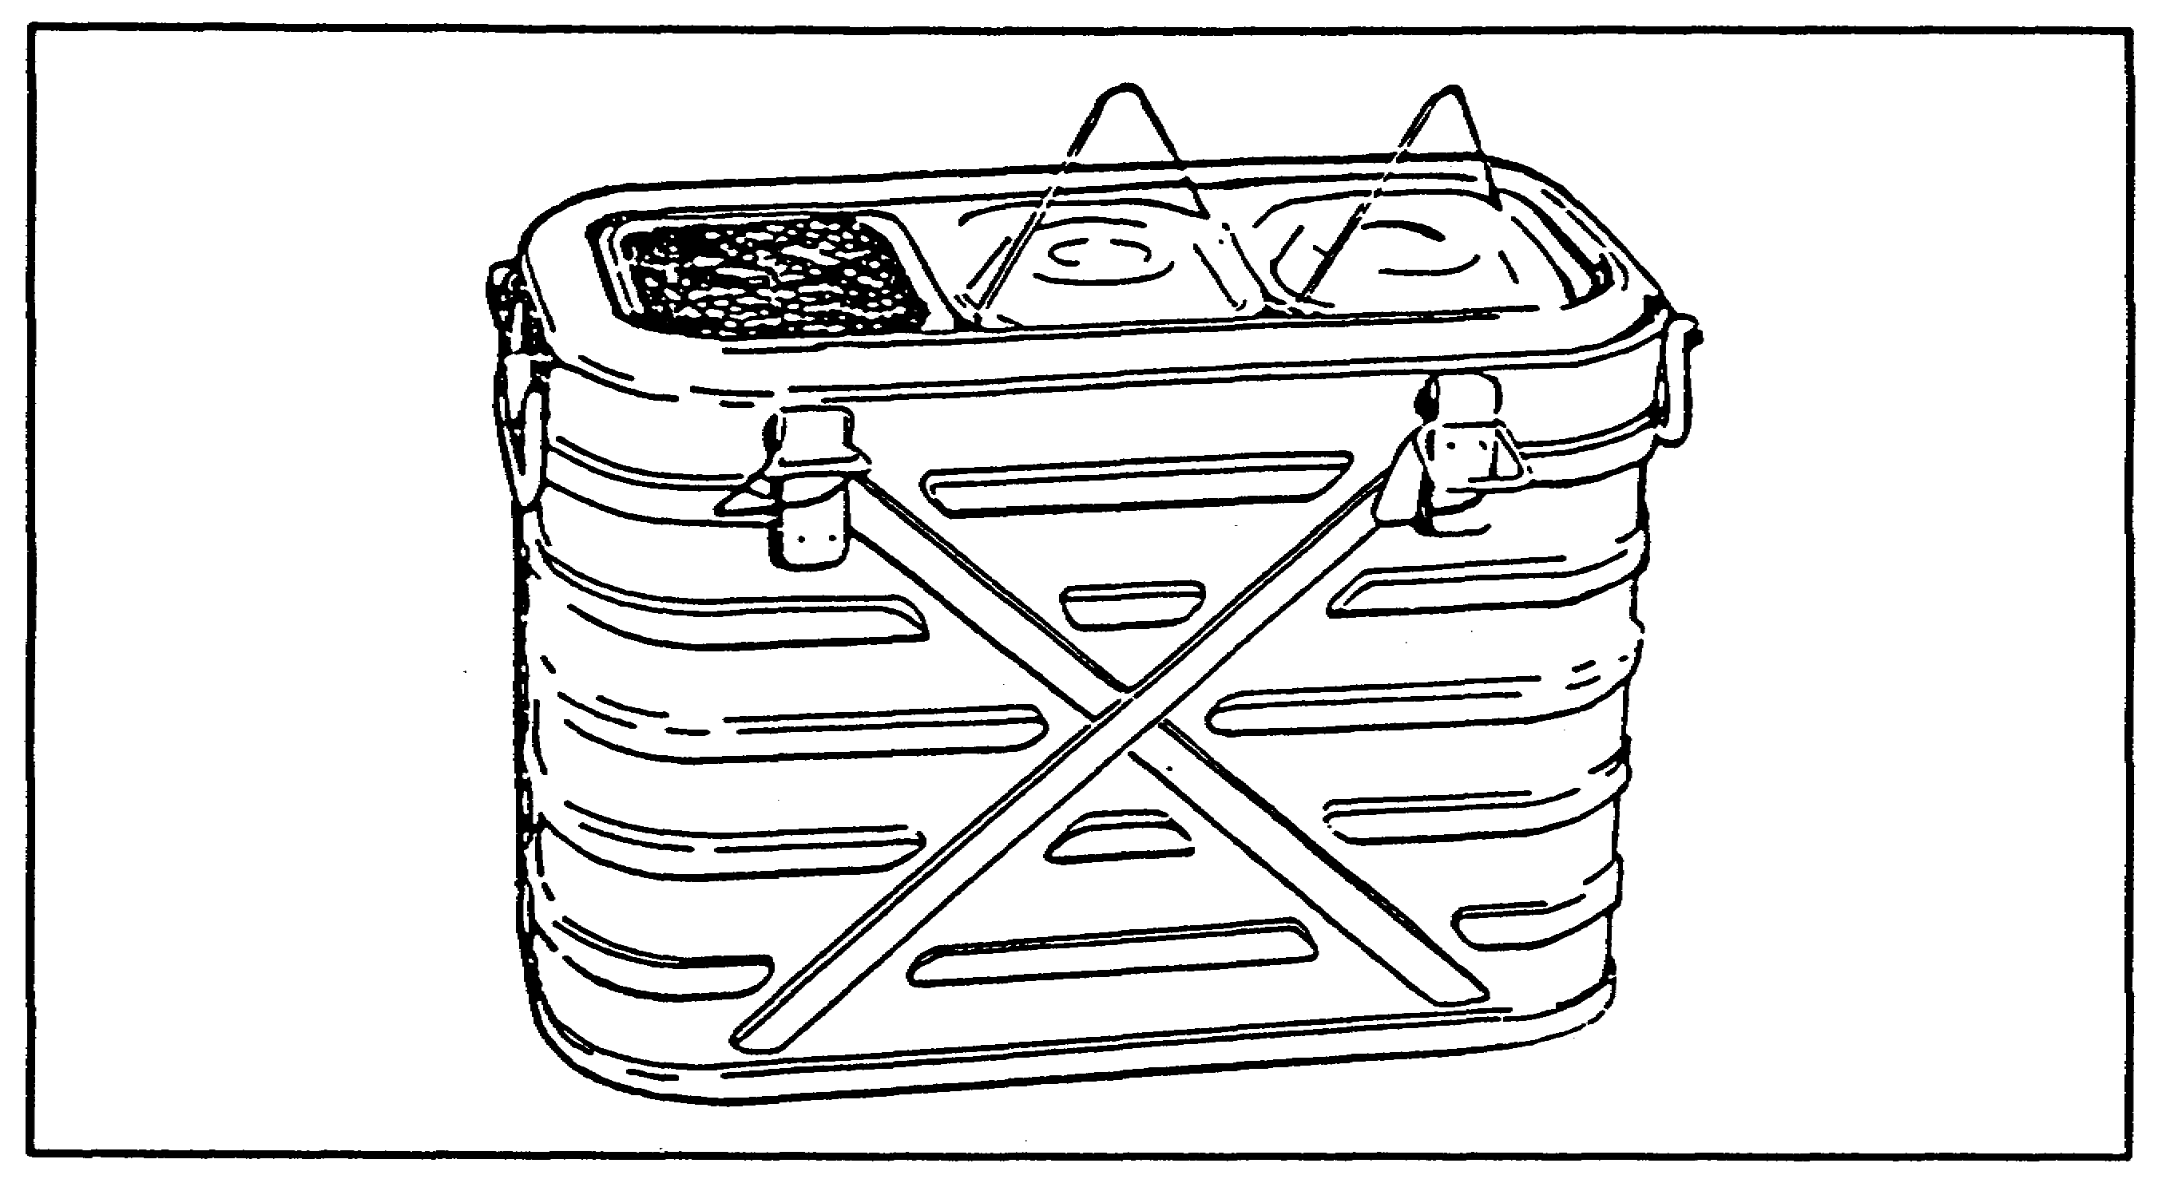

Figure 17. Insulated Food Container.

33 QM3853

(8) Insulated Beverage Dispensers. These dispensers (Figure 18) have a 5-gallon capacity and are designed to maintain hot or cold beverages for both on-site and remote-site feeding.

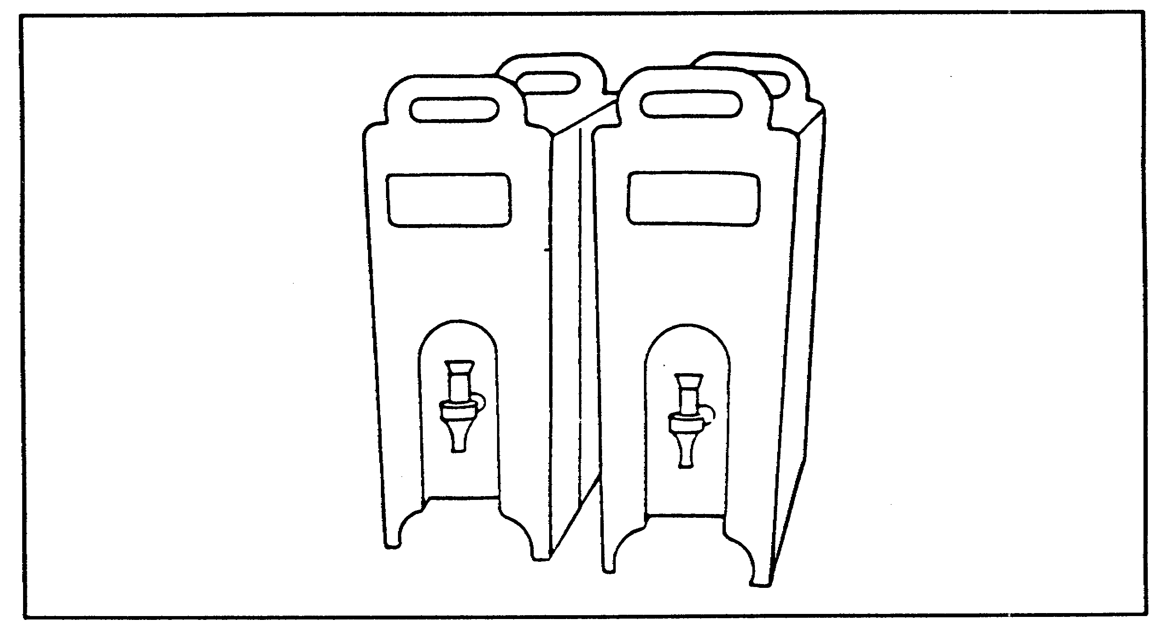

Figure 18. Beverage Dispensers.

(9) Additional Kitchen Components. These components are gasoline and water cans, preparation and serving utensils, and other minor equipment required for food preparation and serving.

c. Setting up the FKM. Use the following procedure to set up the FKM:

o First set up the temper according to paragraph 6d below.

o Then, set up the two worktables.

o Next, remove the four small locking bolts from the legs of the griddle stand assembly, unfold the legs, and replace the locking bolts. Position the griddle stand, and level it using the level adjustments.

o Now, repeat the above steps for the steam table assembly.

o Next, assemble the exhaust assembly, and position it between the griddle and steam table stands.

34 QM3853

o Then, assemble the steam top, and place it on top of the steam table assembly.

o Now, place the oven on top of the burner base, and install the burner in the rack. Repeat the steps above for the second oven.

o Next, place the pot cradle on top of the burner base, and install the M2 burner unit. Repeat these steps for the second pot cradle assembly.

o Then, assemble the storage and drying rack.

o Next, place the storage cabinet assemblies in the desired position.

o Now, position the beater cabinet with the drain hose.

o Next, attach the can opener to the appropriate worktable.

o Then, arrange the meal carriers and remaining accessories in accessible Locations.

d. Temper. The FKM is housed in a frame-supported, 16 feet long by 20 feet wide (two eight-foot sections), temper. The fabric for one 8-foot section is provided with doorways on each side and screened roof vents with flaps. Fabric for the other section is provided with windows on each side and one stove pipe opening. The roof vents are designed to remove excess kitchen heat and/or fumes. For cold weather operations, the temper is equipped with a cotton liner, and if needed, an additional insulated liner. The temper also has a tent fly to reduce the solar load in hot environments and to permit the roof vents to be opened in inclement weather. The temper frames and fabric can be hooked together to form a shelter of any length in 8-foot sections. TM 10-8340-224-13&P gives more detailed instructions.

(1) Inspection. When the shipping container is received, it should be inspected carefully for any damage that may have occurred during transport. Damaged shipping containers indicate damage may have occurred to the enclosed tent. Inspect the unpackaged tent compartments to ensure that all components are present and any missing components are reported to the proper authority. To ensure that the temper is always ready for use, inspect it systematically to detect defects and have them corrected before they cause serious damage or failure. Note defects found while the shelter is being used. As soon as its use is discontinued, have the defects corrected. If a deficiency is noted which would damage the shelter with continued use, stop use immediately. All deficiencies and shortcomings will be

35 QM3853

recorded together with the corrective action taken on DA Form 2404 as soon as possible.

(2) Site Selection. Select the site for erecting the temper according to the functional requirements and convenience to other elements of the installation. If possible, select a site which is fairly level with good clearance. Clear the area of rocks, stumps, or debris that might damage the shelter fabric. Ensure there is proper drainage.

(3) Setting Up and Dismantling the Temper. The first step in setting up the field kitchen modular is to set up the temper. The temper consists of an outer fabric with attached ridge and eave guy lines, foot stops, and sections of an aluminum frame assembly. Four to six men can raise the tent in 30 minutes. The tent has four doors, one on each side for serving and one in the center. There are two large screened openings in the roof section with a moveable outer cover, and the sides and ends have large screened openings with foul-weather curtains and a clear plastic covering for light.

NOTE: During installation, carefully inspect all components for holes, tears, and cuts, broken or missing stitching, mildew, or evidence of abrasion or wear. Also inspect attaching and connecting hardware for damaged or unserviceable items and report them to the proper authority.

(a) Operating the Tent Sections. The door and window sections are the two types of tent sections available. These are also available in a desert, tropical, or temperate version. All sections are in 8-foot lengths and have no zippers; the becket lace method is used. Using this method with 2-inch wide Velcro on the weather seal ensures that the connections are weather tight and light sealed. They are designed to keep heavy winds from creating openings or gaps. The following are descriptions of the individual tent sections.

o Two types of sectionalized liners are end section liners and intermediate section liners. Secure them by tie tapes and use Velcro fasteners to attach additional sections. The liners are a light color and can be laundered in standard field laundry equipment.

o The size of the fly sections are compatible to the roof surface area. Connect them by the same method as the tent sections.

36 QM3853

o The sectionalized flexible fabric floor is easy to clean by using readily available cleaning supplies. It contains provisions for being tied down.

o The fabric partition allows the interior tent area to be divided into functional areas. The partition includes a doorway (flap opening) and provisions for being secured to the floor.

o The transition section (vestibule) provides a protective passageway from one tent to another while also providing for blackout protection.

(b) Operation in Extreme Cold. After you lay the ground cloth, erect the tent, hang the arctic liner, and install the tent liner, ensure that all windows, doors, and weather seals are properly installed. The ground cloth helps break ice around the base of the temper. Place heaters along the base of the temper using duct work, and if a large number of sections are used, alternate the heat ducts. Herman Nelson heaters work well in subzero temperatures. Snow can be packed around the base of the tent to prevent cold air from leaking into crevices. Becketing hooks help when untying frozen laces in cold weather when insulated gloves are worn. Be sure a way is provided for the M2 burner gases to escape when using the cold weather kit with the temper. For example, make an opening at the top of the tent through places where the liner meets. You also can open the tent vent.

NOTE: Carbon monoxide danger is greatest when winds are calm or still. It is reduced when winds are even slightly moving. As a precaution, ensure that food service personnel rotate kitchen and outside duties and follow all safety precautions in TM 10-7360-204-13&P.

(3) Maintenance. To erect the temper properly, you must follow certain maintenance procedures. No special tools or equipment are required to maintain the Temper. However, in arctic regions, the becketing hook is essential, especially in untying frozen laces. A pin puller is also essential when tent pins are frozen in the ground. Both items can be manufactured locally. A 2 1/2-pound sledge hammer is also useful in arctic regions. Figure 19 shows a becketing hook and pin puller.

37 QM3853

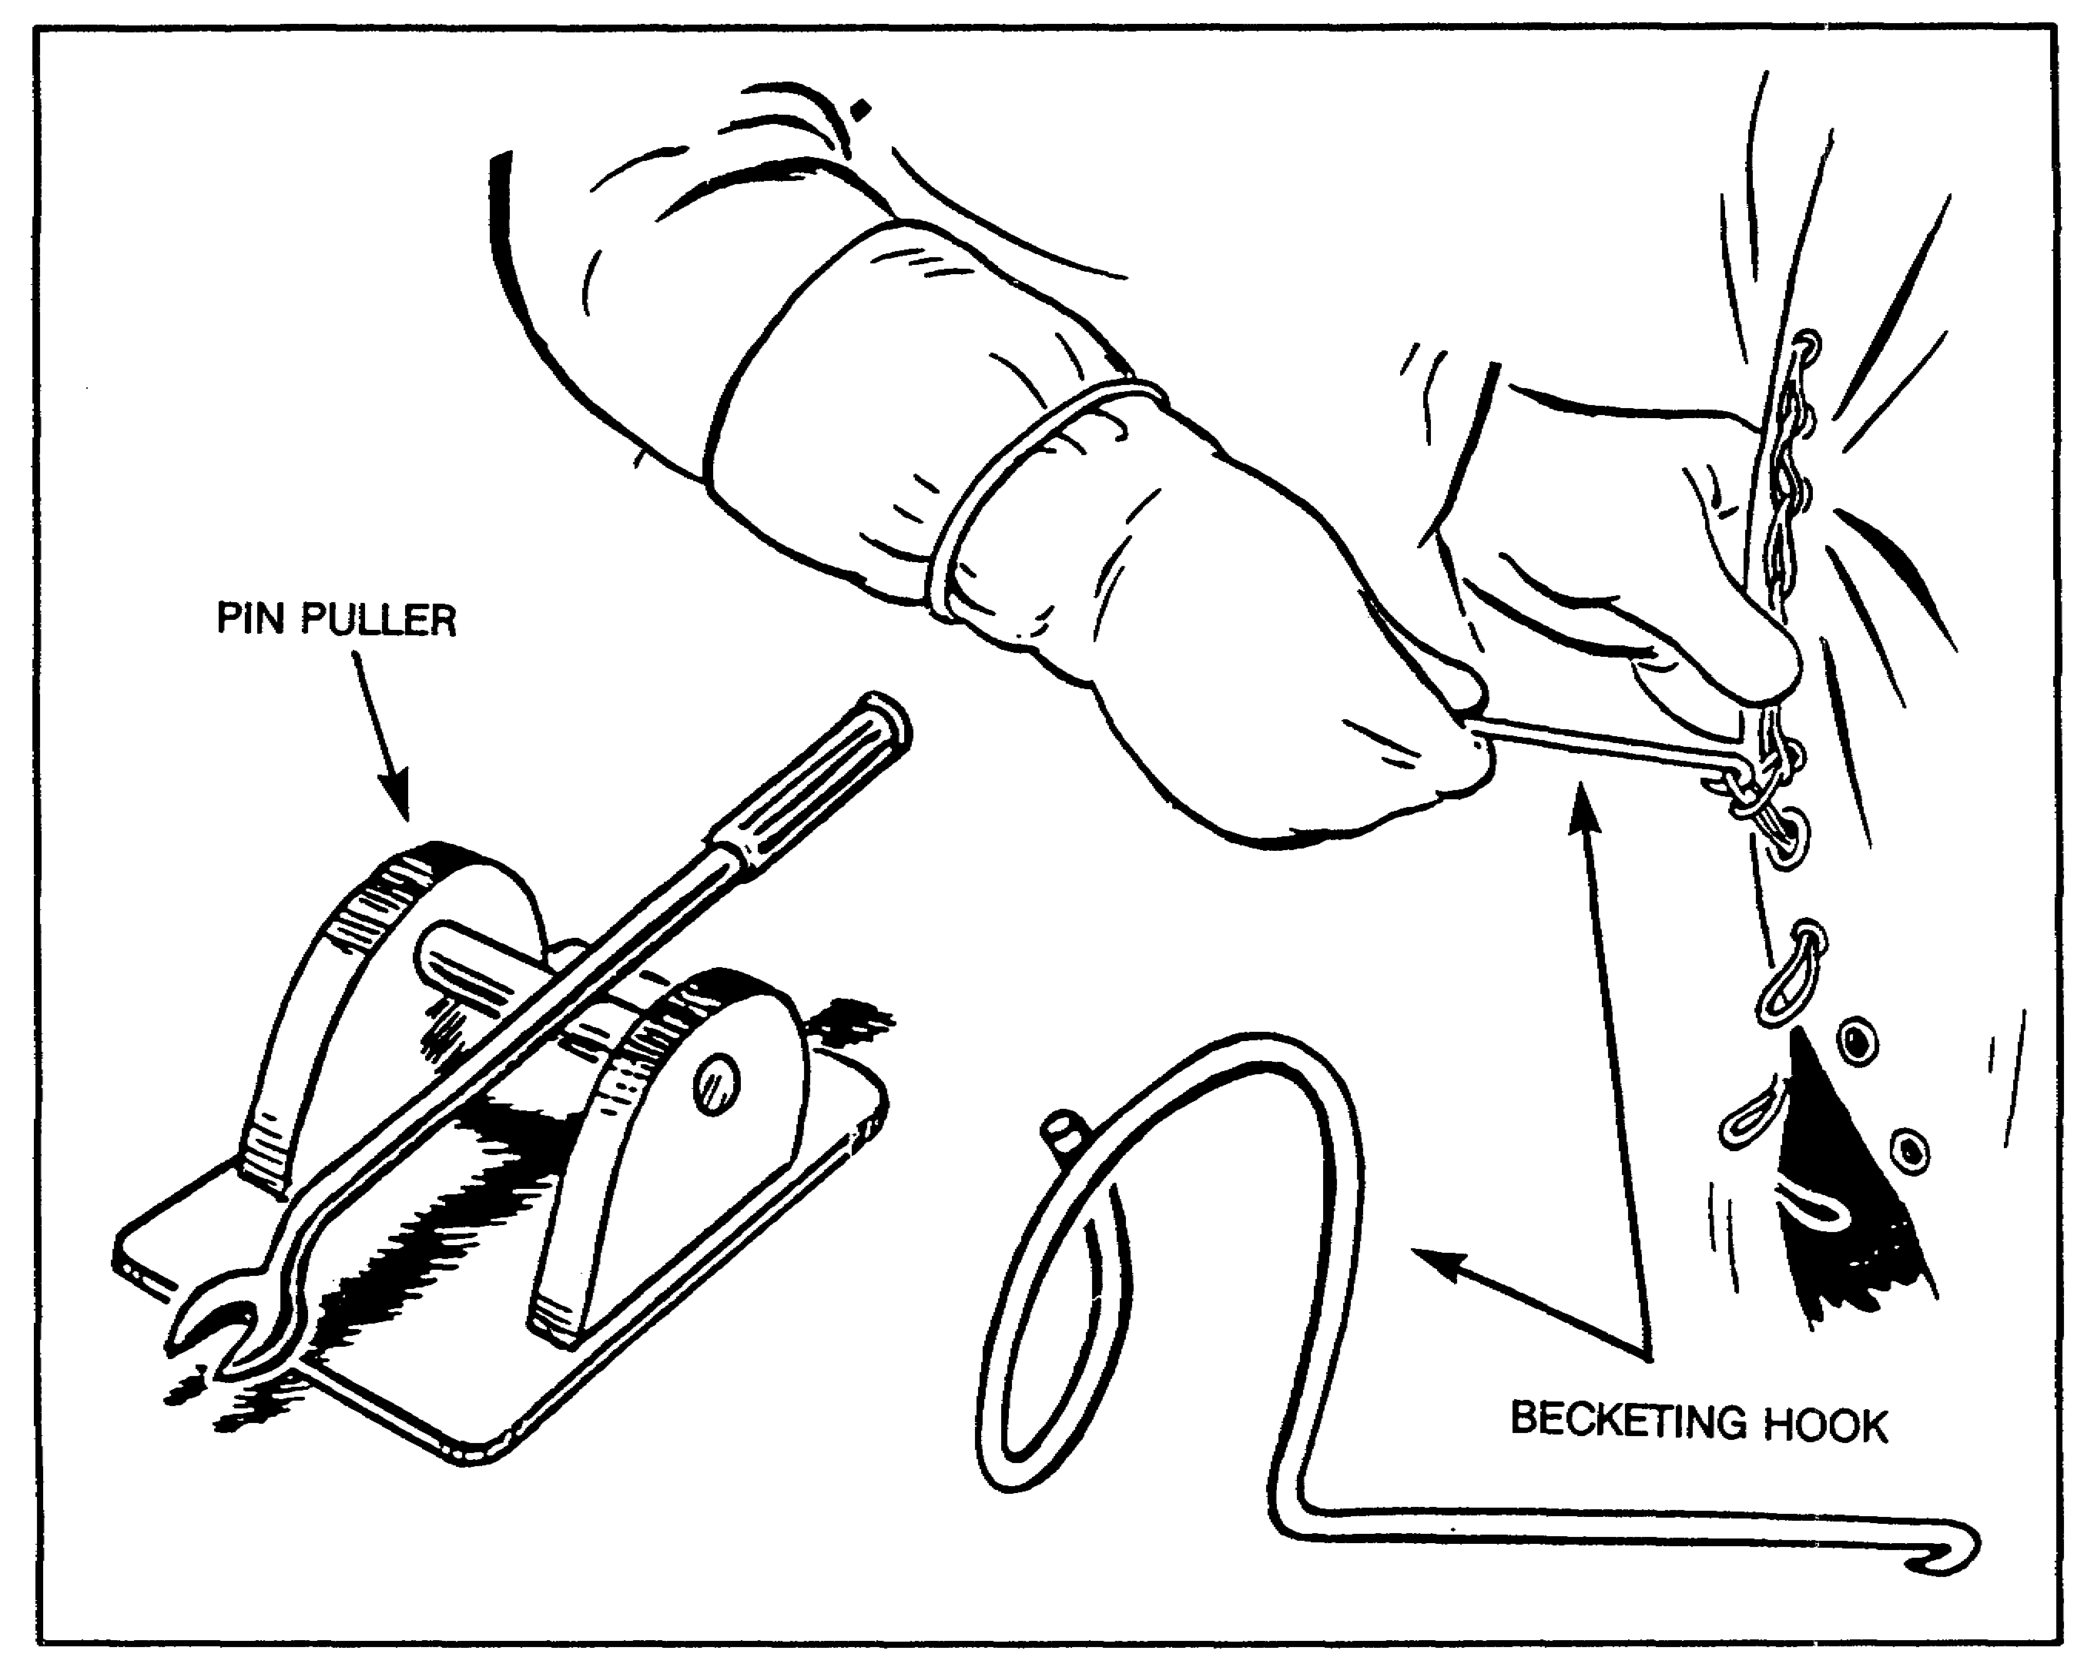

Figure 19. Becketing Hook and Pin Puller.

PART C - COORDINATE WITH THE SURGEON ON SANITATION, NUTRITION,
NUTRITION SURVEYS, AND MENU TESTING

1. Responsibilities of the Surgeon General (TSG).

Some important responsibilities of TSG include establishing dietary standards, recommending appropriate changes to food service facilities, and developing menus.

a. Establish Standards. TSG establishes appropriate nutritional and dietary standards for personnel subsisted under normal and special operating conditions (for example, arctic, desert, and tropical climates).

b. Provide Guidance. TSG provides guidance on the ideal weights for personnel and methods for achieving them.

38 QM3853

c. Provide Representatives. TSG provides qualified representatives to do the following.

o Advise and serve as liaison with procurement personnel, food service personnel, and local menu boards (when applicable) to obtain and maintain nutritional adequacy of food served under various operating conditions.

o Assist in instructing food service personnel in the fundamentals of nutrition education, personal hygiene, and food service sanitation.

d. Recommend Changes. TSG reviews and recommends appropriate changes to standards for design, construction, operation, and maintenance of facilities and equipment where food is stored, processed, and served to comply with health and sanitation standards.

e. Develop Menus. TSG develops hospital B Ration menus, special hospital menus, and modified diet menu items for nonfixed medical treatment facilities.

f. Coordinate Research and Development. TSG coordinates research and development of medical field feeding with the appropriate activities.

g. Review Requests. TSG reviews requests for supplemental food allowances exceeding 8 percent for patient feeding in nonfixed medical treatment facilities prior to referral to HQDA (DALO-TST-F), WASH DC 20310-0564.

2. Overview on Sanitation.

You should advise commanders and dining facility officers and managers on sanitation. Also make sure that food handlers and managers are trained to know the causes of foodborne illness so they can take steps to eliminate them. Figure 20 lists causes of food contamination and ways to prevent or eliminate them. For example, one listed cause of contamination is the presence of contaminated food supplies. Two methods used in preventing this are veterinary inspection upon receipt and issue and checking food and drug activity messages to see which foods are listed as being contaminated.

The preventive medicine officer inspects dining facilities regularly and brings standard violations to your attention. However, if food handlers and managers are well-trained and supervision is effective, there may be no violations. All of your food service personnel must be trained in sanitation. You may request assistance in sanitation training from the

39 QM3853

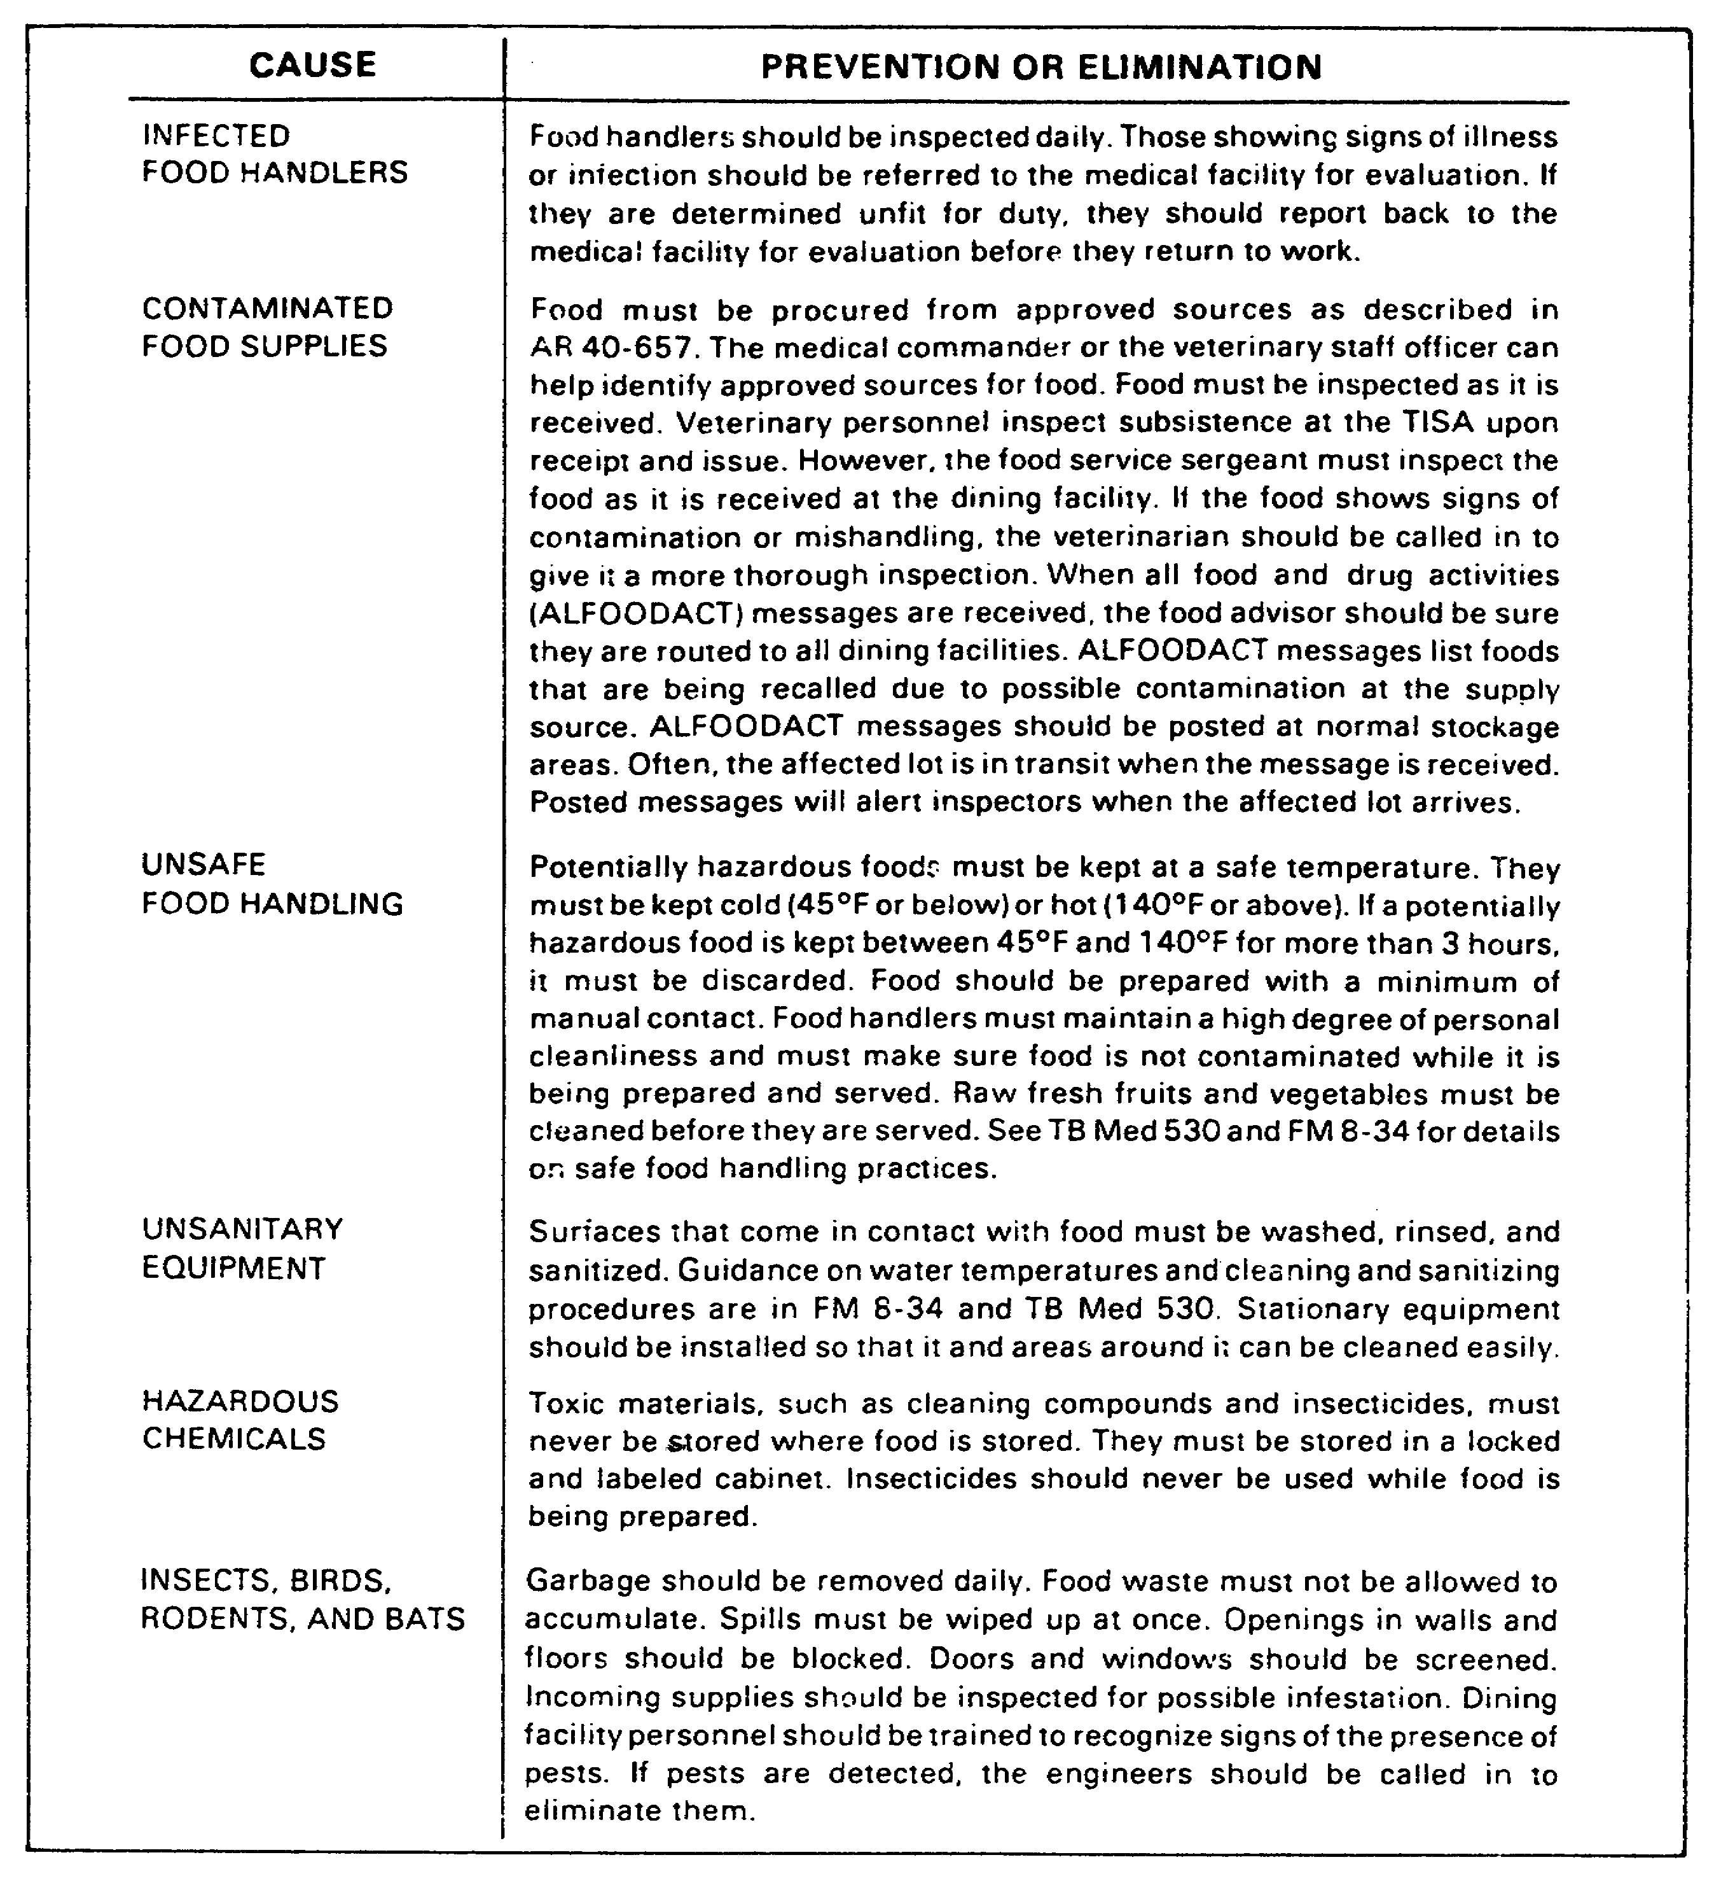

Figure 20. Causes of Contamination.

Installation Medical Authority (IMA) or the preventive medicine activity, which provide supervisor training. They use a course of instruction which meets requirements detailed in US Department of Health and Human Services publication (Food and Drug

40 QM3853

Administration (FDA)) 76-1009. The National Institute for the Food Service Industry (NIFI) course, Applied Food Service Sanitation, is recommended. If training is not locally available, you can send supervisory personnel to the Quartermaster School for sanitation training. When supervisors are trained, they can train their subordinates.

3. Personnel Hygiene.

Dining facility personnel must have excellent personal hygiene to handle food. Poor hygiene of food handlers can lead to the transmission of foodborne disease and subsequent illness outbreaks within a unit. Be sure your workers understand the importance of good personal hygiene practices and sanitary food preparation methods.

a. Personnel Issues. Only qualified personnel are authorized to prepare foods.

(1) Food Service Attendants. Food service attendants (contract civilian, local nationals) who are not fully qualified can, when authorized by the installation medical authority (IMA), be used to serve food or to perform limited food preparation.

(2) Military Personnel. Military personnel detailed by the daily duty roster can serve food and perform limited food preparation duties such as preliminary vegetable preparation.

(3) Unauthorized Personnel. Unauthorized personnel are not allowed in the food preparation, storage, or equipment or utensil-washing areas of a food service facility. Signs should be posted to this effect.

b. Employee Health.

(1) Clearance From the Installation Medical Authority (IMA). No person may work in a food service facility in any capacity unless cleared for specific duty by the IMA while--

o Infected with a communicable disease that can be transmitted by foods or who is a carrier of organisms that cause such a disease.

o Having a boil, infected wound, or acute respiratory infection.

(2) Personnel Inspections. Supervisors inspect all personnel daily at the start of the work period. People who exhibit signs of illness including skin diseases, diarrheal illness (admitted or suspected), burns, boils, or cuts are

41 QM3853

referred to the IMA for evaluation. Particular attention is given to the following personnel.

o Food service attendants specifically authorized by the IMA to serve or handle food and to sanitize equipment and utensils.

o Detailed military personnel.

(3) Medical Evaluations. Personnel referred for medical evaluation provide their supervisors with a written statement signed by a physician giving duty limitations, if any, or stating that the individual is fit for duty as a food service employee.

c. Medical Examinations.

(1) Preemployment and Periodic Medical Examinations. Preemployment and periodic medical examinations of food service personnel within the continental United States (CONUS) are not usually required. Such examinations can give a false sense of security to employees and supervisory personnel. Emphasis and resources should be instead placed on training food service personnel in personal hygiene, food sanitation, and disease control.

(2) Communicable Diseases. People who have been absent from work because of a communicable disease (including a diarrheal disease) should be referred to the IMA for a determination as to fitness for duty before resuming work. Those so referred are evaluated, and if found fit, are given a written clearance signed by a physician authorizing return to duty as a food service employee.

d. Personnel Cleanliness. Employees are to maintain a high degree of personal cleanliness and conform to good hygienic practices during all working periods in the food service facility.

(1) Uniforms. All food service personnel are given a clean uniform daily. Except during field operations, white, pastel, or other light-colored uniforms that easily show soil or dirt accumulation are worn by all employees, including ware washers and permanent food service attendants. This does not apply to personnel while stocking canned, packaged, or otherwise fully protected foods or to checkout clerks in retail food stores. Military personnel detailed by daily roster to work as food service attendants and who are authorized on the serving line or in food preparation areas wear clean, light-colored uniforms or aprons over clean duty uniforms. Wearing round-necked T-shirts as an outer garment is acceptable while performing custodial duties.

42 QM3853

(2) Jewelry. Except for plain wedding bands, food service personnel may not wear any jewelry, including bracelets, watches, or other similar items while preparing or handling food.

(3) Hair Restraints. Effective hair restraints must be used by all personnel working in food service facilities. Hair restraints are to prevent hair from falling into food or on food-contact surfaces and must be kept clean. Determining the adequacy of such restraints is a command responsibility. Personnel with hair (including facial hair) that cannot be adequately restrained are prohibited from food service
operations.

(4) Fingernails. Personnel are to keep their fingernails cleaned and trimmed.

e. Employee Practices.

(1) Consuming Food. Employees are to consume food only in designated dining areas. An employee dining area must be located where contamination of other food, equipment, utensils, or other items needing protection cannot occur. This requirement is not intended to prohibit recipe testing or consumption of drinking water. Recipe testing is done using clean, sanitized utensils and portions withdrawn for testing must be discarded as food waste. Utensils used must be cleaned and sanitized before reuse.

(2) Using Tobacco. Personnel are not to use tobacco in any form while engaged in food preparation or service, or while in equipment and utensil washing or food preparation areas. An area should be designated where personnel are allowed to use tobacco, and personnel may not resume work after using tobacco without first washing their hands. Signs should be posted to this effect.

(3) Washing Hands. Personnel must thoroughly wash their hands and exposed portions of their arms at the beginning of duty, after using toilet facilities, using tobacco, between handling soiled and clean utensils and equipment, between handling raw and cooked foods, after performing custodial duties, including handling garbage or trash, and as often as necessary to maintain a high level of personal cleanliness. Signs should be posted to this effect.

(4) Performing Custodial Duties. Personnel who handle or serve food may not clean latrines, garbage cans, sewers, drains, grease traps, or perform similar custodial duties during the period of food preparation. This is not intended to cut down on cooks' responsibilities to maintain "clean-as-you-go"

43 QM3853

procedures, or to prohibit personnel from performing custodial duties at the end of their shifts.

4. Food Storage.

Proper food storage reduces contamination and improves shelf life.

a. Food Removed From Containers. If raw or prepared food is removed from the container or package it was obtained in, it is stored in a clean, covered container. Container covers are to be impervious and nonabsorbent, except that clean linens or napkins can be used for covering bread or rolls. Solid meat cuts must be protected by being covered in storage, except that quarters or sides of meat can be hung uncovered on clean, sanitized hooks if no food product is stored beneath the meat. Where dissimilar species of raw meats or raw and cooked items are stored in the same refrigeration unit, physical separation or other effective product protection must be provided to prevent cross-contamination.

b. Bulk Lots of Food. Containers or bulk lots of food must be stored above the floor on clean racks, dollies, or other easily cleanable surfaces, in such a manner as to be protected from contamination. Storage racks and containers are to be 6 inches above the floor surface. They must be easily moveable to facilitate inspection and cleaning.

c. Exposed Sewer and Water Lines. Except for required automatic fire protection sprinkler heads, food and containers of food must not be stored under exposed sewer or water lines. Storage of food in toilet rooms or vestibules is prohibited. For existing facilities that violate this requirement, the IMA determines the need for drip pans or other corrective action.

d. Washed and Cooked Food. Food not subject to further washing or cooking before serving is stored so it is protected from contamination.

e. Nonacidic Bulk Food. Whenever possible, nonacidic bulk food, such as cooking oil, syrup, salt, sugar, or flour, is stored in the original product package or container. If transfer is required, the storage containers are labeled with the common name of the food. For storage of bulk flour, sugar, and other similar items, place clean, disposable food grade plastic liners in metal storage cans. Plastic liners should meet National Sanitation Foundation (NSF) requirements.

f. Galvanized Cans. Galvanized metal cans are not used for storing wet foods or beverages.

44 QM3853

g. Refrigerated Storage. Proper temperature control is the most effective way to minimize the risk of foodborne illness and reduce loss through spoilage.

(1) Maintaining Potentially Hazardous Foods (PHFs). Enough conveniently located refrigeration equipment or effectively insulated containers are to be provided to assure the maintenance of PHFs at required temperatures during storage. Each mechanically refrigerated unit storing PHFs is provided with a numerically scaled indicating thermometer, accurate to ± 3ºF, located to measure the air temperature in the warmest part of the refrigeration unit and to be easily readable. Calibrated recording thermometers accurate to 3ºF can be used instead of indicating thermometers. A zone-type thermometer without temperature graduations is not acceptable.

Refrigeration equipment intended for storage is to be designed and operated to maintain air temperatures of 40ºF or below to ensure that stored product temperatures are maintained below 45ºF. Refrigeration equipment intended and used exclusively for tempering or thawing frozen foods can be operated at a maximum air temperature of 45ºF.

(2) Refrigerating PHFs After Preparation. PHFs requiring refrigeration after preparation are cooled to an internal product temperature of 45ºF or below within four hours. Rapid cooling is done by using one or more of the following methods to bring product temperature down to approximately 70°F within two hours.

o Quick chilling with ice bath and agitation (stirring mechanically or manually every 15 to 20 minutes).

o Portioning to shallow pans (3 inches or less) or smaller containers and refrigerate.

o Using prechilled pans and containers for portioning products.

o Circulating cold water in kettle steam jackets (where feasible).

o Short-term storage with agitation in walk-in freezer.

o Quick chilling by immersing the cooking container in cold, running water and with product agitation.

45 QM3853

o Spreading sliced or layering solid items in shallow pans, then refrigerating.

o Distributing the product among several refrigerators. During all handling, the food must be protected from contamination by an appropriate covering. Hot food should be covered in such a way as to prevent any insulating dead air space that would retard cooling.

(3) Transporting PHFs. PHFs to be transported are prechilled and held at an internal product temperature of 45ºF or below.

(4) Maintaining Frozen Food. Frozen food must be kept frozen and stored at a product temperature of 0°F or below except that storage of food at 10ºF is acceptable for a period not exceeding seven days immediately before preparation or tempering.

(5) Maintaining Ice for Human Consumption. Ice intended for human consumption is to be potable and covered or otherwise effectively protected from contamination. Ice used for cooling stored food and food containers is not to be used for human consumption.

(6) Covering Containers. All food stored in refrigerated units must be covered or otherwise protected from contamination. Except for unpeeled hard-skin fruits and vegetables, direct storage of raw or prepared foods on refrigerator shelves is prohibited.

h. Heated Storage. Enough conveniently located hot food holding units are to be provided to assure food maintenance at the required temperature during holding. Each piece of equipment used for holding PHFs must be provided with a numerically scaled indicating thermometer accurate to ± 3ºF, located to measure air temperature in the coolest part of the unit and to be easily readable. Recording thermometers accurate to ± 3ºF can be used in place of indicating thermometers. Where it is impractical to install thermometers on equipment (such as hot food tables, steam tables, steam kettles, heat lamps, cal-rod units, or insulated food transport carriers), a product thermometer is used to check the internal product temperature.

(1) Internal Temperatures. The internal temperature of PHFs requiring hot holding or PHFs to be transported must be 140°F or above.

(2) Hot Food Storage Units. Steam tables, warmers, or other hot food storage units are not designed or considered

46 QM3853

adequate for the rapid heating of PHFs. Food must be heated above 140ºF before placement in such holding equipment.

5. Menus.

As a food advisor, you have several responsibilities in the area of nutrition. You work with the surgeon's representative to make sure the menus provide the nutrients needed by the diners. You also make sure soldiers are able to select food items to meet their individual needs from those meals served in the dining facilities; that storage, preparation, and service procedures do not cause unnecessary nutrient loss; and that there is a nutrition education program available for both food service and unit personnel.

a. Soldier's Needs. If the FSS uses the Master Menu as a guide for menu planning, soldiers should receive well-balanced meals with all required nutrients. However, under Army Ration Credit System (ARCS), the FSS can make substitutions. Periodically check menus to see if suitable substitutions have been made. Base your evaluations and advice on the basic four food groups and dietary guidelines. Make sure low-calorie items are available to diners.

b. General Nutritional Standards. The Army has established basic standards to ensure a comprehensive nutrition program. Food service programs must comply with AR 40-25 and adequately meet soldiers' daily nutritional needs.

c. Menu Standards. Nutritional menus for dining facility used must--

o Provide a low-calorie menu for each breakfast, lunch, and dinner, as specified in SB 10-260.

o Provide a low-calorie menu for the short order line (when operational), as specified in SB 10-260.

o Include the following items daily:

- A variety of menu items of contrasting texture, flavor, and color.

- Unsweetened, ready-to-eat, and whole grain cereals (breakfast).

- Fresh fruit (or canned, if fresh is not available) or unsweetened juice.

o Include noncaloric beverages, unsweetened or prepared with an authorized sugar substitute.

47 QM3853

o Make margarine available as a spread.

o Include whole grain breads and rolls.

o Include low-fat (2 percent) milk as the primary milk source in bulk dispensers, with whole milk as an alternate at all meals. Low-fat (1 percent) milk, skim milk, buttermilk, and low-fat chocolate-flavored (2 percent) milk can also be offered.

o Include-low calorie dressings.

o Include an herbal seasoning mixture (a blend of sodium-free herbs and spices), when available, for table use. Commercial salt substitutes are prohibited. Table salt is permitted for diner use.

o Include authorized, granulated, non-nutritive sugar substitutes in lieu of granulated sugar.

d. Menu Planning Considerations. Nutritional standards represent only one of several menu planning considerations emphasized by the Army. The following subparagraphs discuss some of the other considerations.

(1) Food Habits. Factors affecting personnel eating habits are their residence, cultural background, and religion, as explained below.

o Area of residence: Certain foods which are considered highly acceptable in one part of the country may not be acceptable in other parts.

o Cultural background: Ethnic origin can determine a person's initial orientation to food and its preparation. This may result in strong personal food preferences.

o Religion: Note that certain food items and the number of meals consumed are dictated by some religions.

(2) Occupation. Consider the effects of work performed and other physical activities on soldiers' appetites.

o Personnel in a unit required to perform heavy physical work generally have larger appetites and therefore consume more food than those in units performing less physically strenuous work.

48 QM3853

o Troops who choose to increase their level of physical activity through exercise require more calories in their diets.

(3) Preference of the Troops. Consider whether the food served is acceptable to the soldiers.

o If a food item is acceptable to the majority of troops, it may be acceptable as a leftover.

o A food item consistently discarded by troops may indicate it is unacceptable.

(4) Staying Qualities of Food. The menu offered in the dining facility should satisfy the hunger of the troops until the next meal.

(5) Availability of Food. Food items purchased locally are easier to obtain and are usually cheaper than those that must be transported. With current transportation methods, food products can be obtained in most locations.

(6) Cost. The season, special ordering, and the cut of meats can affect the cost of preparing meals.

o Seasonal items: Take advantage of foods in season in your local area.

o Special orders: Limit food purchases outside the system. They are often more expensive.

o Cut of meat: Less expensive cuts of meat, prepared properly, can be just as satisfying to troops as more expensive cuts.

(7) Leftovers. Meals should be planned with the expectation that there will be no leftovers. When there are leftovers, they must be used at the next meal, but served differently. Remember that leftovers lose nutrients through additional handling, preparation, and storage, and highly perishable foods cannot be saved for next-meal use.

(8) Keeping Qualities. The keeping qualities of foods are to be considered when planning menus.

o Limit highly perishable foods on the menu; they can be hazardous if mishandled. As mentioned earlier, they cannot be saved after meal service.

49 QM3853

o Preparation of highly perishable foods requires tighter time and temperature schedules. This can result in increased personnel needs and food costs.

(9) Variety of Foods. When planning, consider the appearance, taste, texture, and the use of local foods.

o Provide menu variety by including local, cultural, or ethnic food items.

o Food colors are important to soldiers. If possible, provide garnish to improve serving line appearance.

o Provide different flavors or textures. Monotony can result in diner dissatisfaction. A variety of soft, crisp, sweet, and spicy foods should be provided at each meal.

e. Basic Four Food Groups. The four food groups are the meat group, milk group, grain group, and fruit and vegetable group. A nutritious diet must contain servings from all four groups. Figure 21 shows the food groups and gives examples of the types of food items in each group. The figure also shows the minimum number of daily servings for each food group for adults and for teenagers. Additionally, Figure 21 lists the approximate serving sizes for items in each food group. Figure 22 gives more data on the food groups by listing the leading nutrients in each group and other nutrients they offer. For instance, the meat group is highest in protein, and also provides thiamine, niacin, and iron. Not all foods fit into one of these groups, however. Foods that do not are generally high in calories and low in nutrients. These foods are listed in the "others" category in Figures 21 and 22.

f. Function of the Menu Board. The menu board reviews SB 10-260, SB 10-263, or other special menus. It can alter the menu to meet the command or installation needs and diners' desires. AR 30-1 gives details on menu changes. Listed below are some authorized reasons for menu changes.

o To add nutrients recommended by the surgeon.

o To make changes directed by ACES or the Defense Personnel Support Center (DPSC).

o To substitute items for those in the published menu that are unavailable.

50 QM3853

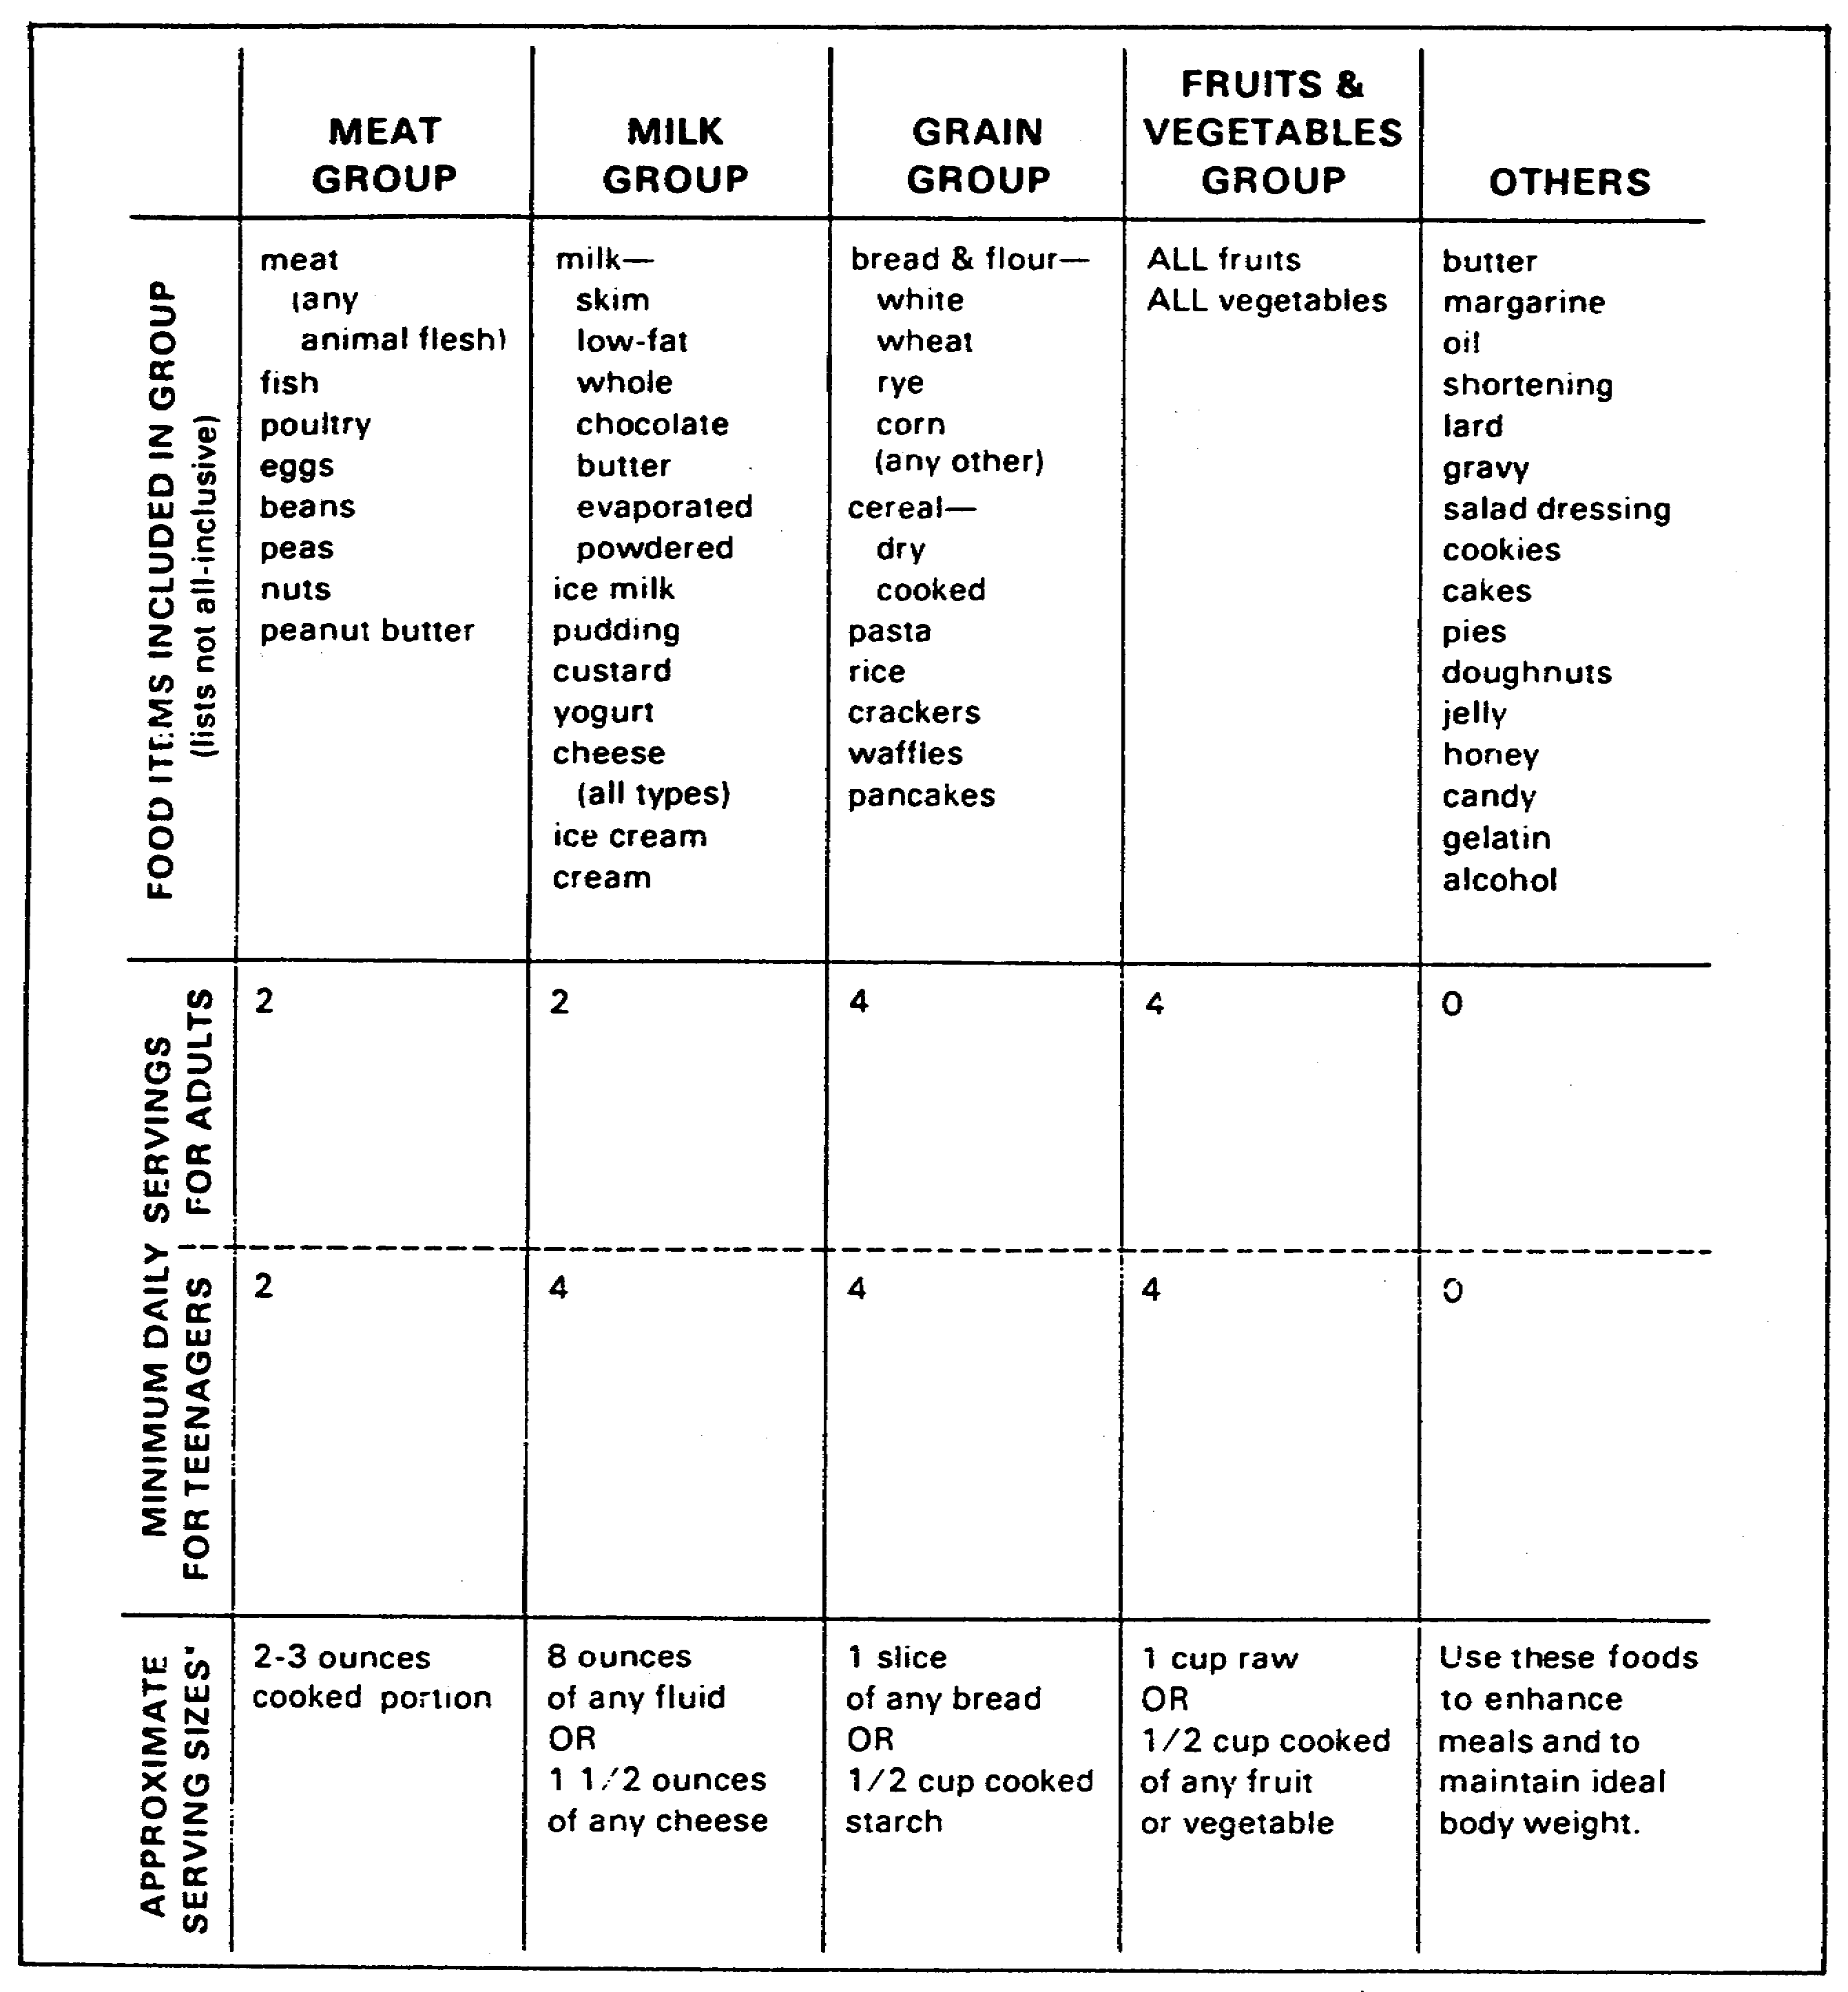

Figure 21. Basic Four Food Groups.

o To incorporate items that are in excess of normal requirements.

o To use fresh, locally grown fruits and vegetables as authorized by DPSC.

51 QM3853

o To meet the food preferences of soldier ethnic groups.

o To provide low-calorie food items to meet diner preferences and varied nutritional requirements.

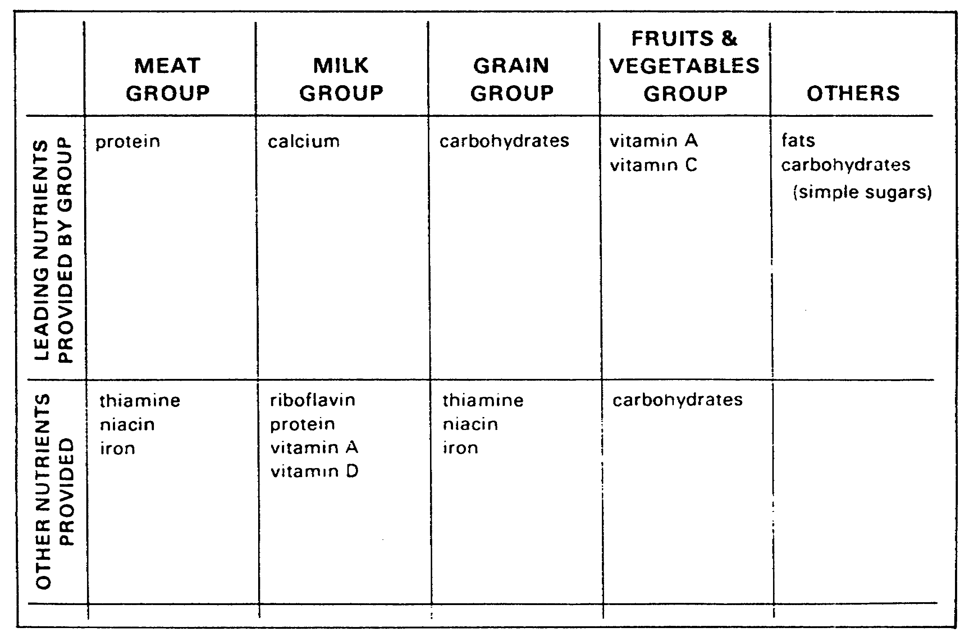

Figure 22. Leading Nutrients in Food Groups.

PART D - COORDINATE WITH VETERINARY PERSONNEL CONCERNING
UNSATISFACTORY SUBSISTENCE PRODUCTS

1. General Responsibilities of the Veterinary Officer.

The veterinary officer conducts the sanitation inspections and other veterinary inspections during food procurement, processing, storage, receipt, and distribution. The veterinary officer inspects food as it is received at the TISA. You work with him to ensure sanitary conditions for food storage are maintained. You also work with him on forced issues, stock rotation, commercially prepared dairy and bakery product delivery, and unsatisfactory products.

When there is a loss of subsistence, you coordinate with the veterinary officer to determine the cause and circumstances

52 QM3853

surrounding the loss. A possible cause for deteriorated subsistence is improper storage procedures or subsistence that has been in storage too long. If subsistence deterioration is caused by negligence, you must take steps to ensure that personnel know and follow procedures to protect subsistence.

DA Form 3161 (Request for Issue Turn-in) is used to record subsistence losses. As the food advisor/technician, you are responsible for reviewing the form and following up on the report.

2. Reporting Unsatisfactory Subsistence Items.

a. Submitting DD Form 1608 (Unsatisfactory Material Report). Subsistence items with unsatisfactory product characteristics, unwholesomeness, or poor quality that do not conform to required specifications detract from the worldwide Army Food Service Program. DD Form 1608 is submitted by anyone who can provide information concerning the fitness or suitability of subsistence used in Army dining facilities, regardless of the supply source.

b. Coordinating With Personnel to Submit Report. Food service personnel participation in reporting unsatisfactory subsistence is required. Preparation instructions are provided on the reverse side of DD Form 1608, and a list of descriptive terms and complete instructions are in AR 30-16. It may be necessary to coordinate with installation veterinary and TISA personnel for technical assistance. Completed forms are forwarded through the installation food advisor to the Army Center for Excellence, Subsistence, Fort Lee, VA 23801-5041. Information obtained is used to take corrective action.

3. Condemnation Losses.

When veterinary personnel or the appropriate medical staff determines that subsistence is unfit for human consumption, it is destroyed by the authorized dining facility personnel; this disposition method requires a Certificate of Unfitness. In addition, the items are listed on DA Form 3161 with the following statement signed by a disinterested person (officer, senior NCO, or civilian (GS-9 or above)) witnessing the destruction: "Disposal of the above subsistence was accomplished on (date) for the dining facility by (landfill, contractor, dumpster)." DA Form 3161 and the veterinary Certificate of Unfitness is forwarded to the TISA (as prescribed in AR 30-18).

a. Preparation of DA Form 3161.

(1) Responsibilities of the Troop Issue Subsistence Officer (TISO). DA Form 3161 is used to list items and record dollar amounts. The TISO does the following.

53 QM3853

o Prepares a separate DA Form 3161 for perishable and semiperishable subsistence items.

o Leaves block 1 blank unless items have a resale value as animal feed. If this occurs, the name and address of the property disposal office is entered.

o Enters "Last Item" underneath the last item.

o Places the following statements on the front of DA Form 3161. The installation military veterinary service personnel (VSP) office, TISO, and a witness sign the proper statement.

- VSP officer: "The subsistence items listed above have been inspected and are unfit for human consumption/ intended use."

- TISO: "The subsistence items listed above are unfit for their original intended use. There is no evidence that the damage or deterioration was due to the fault or neglect of TISA personnel. Items above have no sale value."

- TISO: "The subsistence items listed above were damaged as a result of (refrigeration failures, power outage, fire, etc.) and a DA Form 4697 has been initiated".

- Appointed witness: "Disposal of the above subsistence was accomplished on (date) for the ___TISA by (landfill) (contractor) (dumpster)."

o Disposes of salvage items before inventory.

o Posts the dollar amount of the salvaged items as a credit to the DA Form 3295-R (Voucher Register and General Control (VRGC)), and to DA Form 3293 (Subsistence Consumption Card).

(2) Example of DA Form 3161. Figure 23 is an example of a completed DA Form 3161. Note that after the stock number and item description, the unit price and total cost are entered and the form is signed by the TISO.

b. Losses Exceeding $200. For losses exceeding $200, a credit entry is posted to DA Form 3980-R (Dining Facility Account Card) upon receipt of a DA Form 4697 (Department of the Army Report of Survey).

54 QM3853

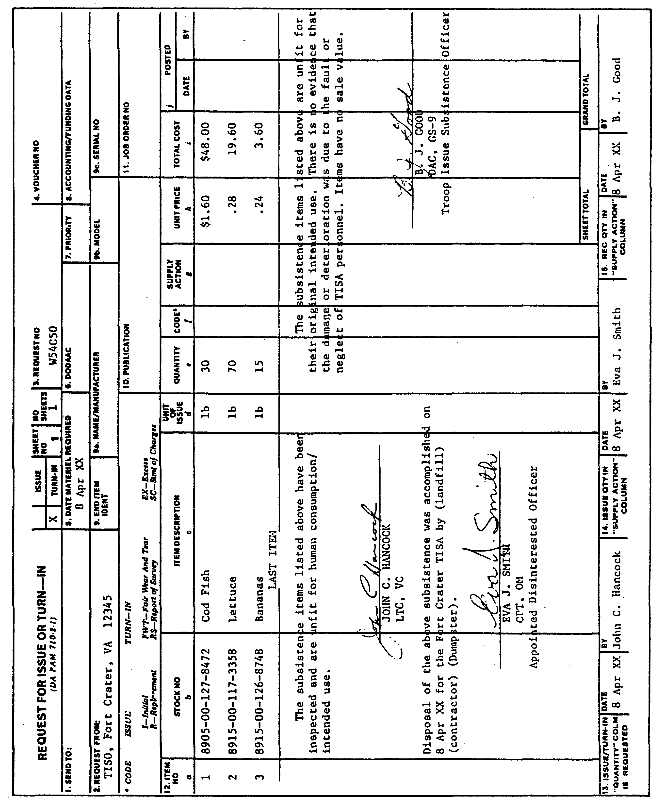

Figure 23. Sample of DA Form 3161.

55 QM3853

c. Losses Under $200. When the total value of items certified for destruction does not exceed $200 and there is no known or suspected negligence involved in the loss, the commander can use the following procedures instead of initiating an RS.

(1) Include a Statement on DA Form 3161. The commander can place a statement on DA Form 3161 certifying that no negligence was known or suspected or the fault of dining facility personnel.

(2) Submit DA Form 3161. The commander can submit DA Form 3161 with veterinary and commander's statements to the RS appointing authority for concurrence/nonconcurrence. Nonconcurrence requires initiation of an RS.

(3) Post a Credit Entry to DA Form 3980-R. The TISA posts a credit entry to the dining facility's DA Form 3980-R upon receipt of the DA Form 3161 with the veterinary Certificate of Unfitness, commander's statement, and the RS appointing authority's concurrence.

4. Disposing of Unfit Subsistence.

a. Unfit Subsistence. Subsistence is disposed when it is damaged or deteriorated and no longer suitable for its intended use as designed in menus, or unwholesome and unfit for human consumption. There is a difference between unsuitable for issue and unwholesomeness. When unsuitable for issue, an item may no longer be usable for its intended purpose due to chemical, physical, or microbial changes. For example, old spices can lose flavor and aroma, or an aged leavening agent may not create a proper baked product. An unwholesome item like spoiled meat can create a health hazard and cause harm if consumed.

The TISO coordinates or schedules surveillance (Class 9) inspections with a supporting VSP and requests monthly inspections for distressed items, until issued or otherwise disposed of.

b. Disposal Procedures. The following procedures are used in disposing of damaged or deteriorated products.

(1) Provisions for Disposal. VSP recommends disposal of items unsuitable for their intended use but fit for human consumption. The TISO segregates and suspends from issue items reported under the Department of Defense (DOD) hazardous food recall program such as ALFOODACT messages. The TISO suspends these items until inspected and disposition instructions are received.

56 QM3853

(2) Surveillance Inspections. Surveillance inspections are to determine wholesomeness or suitability for further storage, issue, and consumption. VSP recommendations for disposition are advisory in nature.

(3) Subsistence With Sale Value. Subsistence items with sales value for purposes like animal feeding are turned in to and signed for by the servicing property disposal officer (PDO).

(4) Subsistence With No Potential Sale Value. Subsistence items with no potential sale value are disposed so as to safeguard public health and safety. Disposal is also to be consistent with Environmental Protection Agency (EPA) requirements. Destruction must be witnessed by a person appointed by the installation commander.

(5) Authorized Witnesses. Witnesses can be DA civilians, warrant officers, NCOs, or commissioned officers. VSP, TISO, or TISA personnel may not act as witnesses.

(6) Certification of Food Items are Unfit. VSP are responsible for certifying that food items are unfit for human consumption. When there is evidence that subsistence items were damaged through an individual's fault or neglect, VSP submit a report of circumstances in writing to the TISO. On receipt of a VSP report, DA Form 4697 is processed by the responsible individual.

(7) Items Purchased Subject to Inspection. When subsistence items have been purchased subject to inspection and accepted at destination, any rejected damaged or deteriorated items are removed by the vendor from the installation.

(8) Damaged Items From Inventory. When subsistence items in the TISO's inventory are found to be damaged or deteriorated, the installation VSP sign a statement that the items are unfit for human consumption or intended use.

(9) Hidden or Latent Defects. If hidden or latent defects are considered causative, VSP can determine if the items should be placed on "hold" status. An Unsatisfactory Material Report should be submitted under AR 30-16, accompanied by a SF 364 (Report of Discrepancy) to request credit. Items are held in "hold" status pending disposition instructions from Defense Personnel Support Center (DPSC). The TISO promptly reports any deteriorated items still within warranty period so recovery action can be taken. When items are on medical hold, they are posted as a memo entry on DA Form 3293-R. Medical hold usually should not exceed one month.

57 QM3853

(10) Salvage Items Marked for Disposal. Salvage items to be disposed of are marked and segregated in a secure area to avoid pilferage. They are stored in closed, cleanable containers like 32-gallon garbage cans with plastic liners.

(11) Extraordinary Circumstances. Subsistence items can be lost or damaged due to extraordinary circumstances for which the TISO had no control. Such circumstances include fire, theft (other than pilferage), explosion, power failure, storms, enemy action, or natural disasters. If one of these occurs, the TISO does the following.

o Contacts VSP to determine fitness.

o Prepares DA Forms 3161 when items are destroyed. VSP sign the statement as described above. The disposal is witnessed by an appointed person, and the statement is signed. DA Form 3161 is not processed as normal salvage.

o Prepares DA Form 4697 for these identifiable losses.

o For losses from refrigeration breakdown, attach the following documents as exhibits to DA Form 4697:

- A temperature maintenance chart.

- DA Form 3161.

- VSP forms.

- A copy of the work order (when applicable).

58 QM3853

LESSON

Practice Exercise

The following items will test your knowledge of the material covered in this lesson. There is only one correct answer for each item. When you have completed the exercise, check your answers with the answer key that follows. If you answer any item incorrectly, study again that part of the lesson which contains the portion involved.

Situation: As the food advisor/technician, you must coordinate with agencies and personnel to ensure that food service requirements are met. Use this situation to answer questions 1 through 8.

1. You have a piece of equipment in the dining facility, but there is no manufacturer's manual for that equipment. One person you may contact to obtain a technical manual for the existing piece of equipment is the

A. Director of Engineering and Housing.
B. Director of Industrial Operations.
C. Director of Resource Management.
D. Director of Plans and Training.

2. A new dining facility is opening, and you want to establish DA Form 2405 (Maintenance Request Register). The person responsible for establishing and maintaining DA Form 2405 is the FSS or the

A. Headcounter.
B. Contractor.
C. Head cook.
D. Engineer.

3. Once an equipment operator and maintenance training schedule is drafted, you submit the schedule for approval to the commander and staff, especially the

A. G2 or S2.
B. G3 or S3.
C. G4 or S4.
D. G5 or S5.

59 QM3853

4. The first step in setting up the field kitchen modular (FKM) is to erect the Temper. How many men does it take to erect the tent within 30 minutes?

A. Two or three.
B. Three or Four.
C. Two to four.
D. Four to six.

5. You are analyzing menus for troops. In considering cost, one thing you keep in mind is

A. The taste and texture of food items.
B. The keeping qualities of food items.
C. Limiting food purchases outside the system.
D. How often a food item is consistently discarded.

6. To prevent using contaminated food supplies, food must be inspected as it is received. Food received at the Troop Issue Subsistence Activity (TISA) is inspected by the

A. veterinary officer.
B. food service officer.
C. food service sergeant.
D. installation food advisor.

7. Subsistence has been certified for destruction. The total value does not exceed $200 and there is no known or suspected negligence. Instead of issuing a report of survey (RS), the commander may place a statement on DA Form 3161

A. Certifying that no negligence occurred.
B. That a Veterinary Certification was issued.
C. Acknowledging that he witnessed the destruction.
D. That a credit entry was posted to DA Form 3980-R.

8. In disposing of unfit subsistence, who is responsible for certifying that food is unfit for human consumption?

A. Food service officer.
B. Director of Security.
C. Troop Issue Subsistence Officer (TISO).
D. Veterinary Service personnel (VSP).

60 QM3853

LESSON

PRACTICE EXERCISE

ANSWER KEY AND FEEDBACK

Item Correct Answer and Feedback

1. A. Director of Engineering and Housing.

Technical manuals are provided with each piece of equipment. The manuals are essential for proper operation and maintenance of equipment. If there is no manual for an existing piece of equipment, contact the Director of Engineering and Housing. You may also contact the installation food advisor to request a manual.
(Page 3, para 2a)

2. B. Contractor.

DA Form 2405 (Maintenance Request Register) is used as an historical record of equipment failures. It is also used to determine uncompleted work requests which require follow-up action. (Page 3, para 2d)

3. B. G3 or S3.

After coordinating with the G3 or S3 for comments and approval, you and your staff can arrange for support, take necessary resource actions, plan for evaluations, and make adjustments as needed. (Page 13, para 2h)

4. D. Four to six.

The temper consists of an outer fabric with attached ridge and eave guy lines, foot stops, and sections of an aluminum frame assembly. Four to six men can raise the tent in 30 minutes. If possible, select a site which is fairly level with good clearance. Also, ensure that the temper will have good drainage. Detailed instructions on setting up and striking the temper are in TM 10-8340-224-13&P.
(Page 36, para 6d(3))

5. C. Limiting food purchases outside the system.

Usually, purchasing food from sources outside the system is more expensive. Cost of purchasing food may be affected by the season, special ordering, and the cut of meat.
(Page 49, para 5d(6))

62 QM3853

6. A. Veterinary officer.

All food must be procured from approved sources as described in AR 40-657. The medical commander or veterinary officer can assist you in locating approved sources. All food must be inspected when received. Veterinary personnel inspect food received at the Troop Issue Subsistence Activity (TISA). (Page 52, para 1)

7. A. Certifying that no negligence occurred.

The commander may submit a report of survey (RS); however, under these circumstances, he is not obligated to submit the report. DA Form 3161 must be submitted to the RS appointing authority with the commander's statement and a statement from the veterinarian. (Page 56, para 3c(1))

8. D. Veterinary Service personnel (VSP).

VSP are responsible for certifying that food items are unfit for human consumption. When food items were damaged through an individual's fault or neglect, VSP submit a report of circumstances to the TISO. (Page 57, para 4b(6))

63 QM3853

